Fire Evacuation, Evacuation off site, Lockdown Evacuation and Invacuation
Brampton Cortonwood Infant School

September 2023

Date for Review: September 2024

- Fire Evacuation
Alert to staff: Alarm
Fire Assembly point: Large School field to the rear of the building.
This signifies an immediate fire risk to the school. The aim of a fire evacuation is for the school and its rooms to be evacuated as quick as possible, and meet at the fire assembly point, located on the school field to the rear of the building.
Immediate action
- The fire bell will be sounded by the Office, SLT, smoke detectors or brake out points (A long continuous ring).

- Smarties will be called KT/EH (Fire drill).

- SLT to phone the emergency services using a mobile phone.
• All pupils/staff must exit their classroom via their nearest fire exit (as stated next to their classroom door).
- Smarties – The fire exit to the rear onto the playground, onto the field.
- F1 Butterflies – Fire exit to the back, onto the large playground, then the school field.
- F2 Owls– Fire exit to the back on the F2 outdoor area, follow through the gate to the hub, then right onto the school field.
- Hedgehogs – Turn right out of the classroom, then right again onto the large playground, then onto the school field.
- Squirrels –Fire exit at the rear of the classroom, turn left and walk to the school field.
- Badgers – Turn left to the fire exit onto the car park, follow the building to the left around to the front school field.

The classroom teacher must collect the fire register upon exit.
• KT / EH will collect the staff and visitor signing in register on their way out, and open the playground gates.
• SLT will sweep the coridoors and toilets before leaving the building, closing doors behind once checked.
• All staff and children must line at the assembly point for their classroom.
• Staff to do head count and register.
• Office staff to do a staff register
• Staff should await further instructions from SLT before going back into the building.
- In the event of danger to staff and children being on school site please see (Evacuation off site procedures).

- Evacuation off site
Alert to staff: 2 long burst of the alarm
Off Assembly point: Cortonwood Comeback Centre (across the road)
This signifies an immediate fire risk or danger to children and staff being on school grounds. The aim of the evacuation is for the school and its grounds to be evacuated as quick as possible, and meet at the off-site location of Cortonwood Comeback Centre, to the rear of the building.
Immediate action
- The fire bell will be sounded by the Office or SLT (2 x long continuous ring).

- Smarties will be called KT/EH (Offsite drill).

- SLT to phone the emergency services using a mobile phone.
• All pupils/staff must exit their classroom via the following fire exits.
- Smarties – The main entrance exit, down the ramp, along the path to the right, walking across the road, turn left up to the Comeback Centre.
- F1 Butterflies – Fire exit to the back, onto the large playground, turn right out of the main gates, follow the path to the front of school and cross the road.
- F2 Owls– Exit via the main classroom door, onto the corridor, turn left using the home time exit, then right towards the front of the building and across the road.
- Hedgehogs – Turn left out of the classroom, out of the main school entrance and straight across the road.
- Squirrels – Fire exit at the rear of the classroom, turn right and walk to the school gates, turn left and then cross the road.
- , turn left and then cross the road.
- Badgers – Turn left to the fire exit onto the car park, follow the building to the left, walk down the driveway towards the road, turn left and then cross the road.

The classroom teacher must collect the fire register upon exit.

• KT / EH will collect the staff and visitor signing in register on her way out, and open the playground gates then stop the traffic in the road for the children and staff to cross.
• SLT will sweep the corridors and toilets before leaving the building, closing doors behind once checked.
• All staff and children must walk safely to the offsite assembly point which is located at the comeback centre across the road. Staff and children must line up at the comeback centre to the back of the building near Dearne Road (see appendix 1)
• Staff to do head count and register.
• Office staff to do a staff register.
• Staff should await further instructions from SLT before going back into the building.
- Staff to contact parents via text using Eduspot from SLT’s phones.

Appendix 1
Please cross the road safely to the comeback centre, walk around to the left of the building, and file to the back see red arrow.
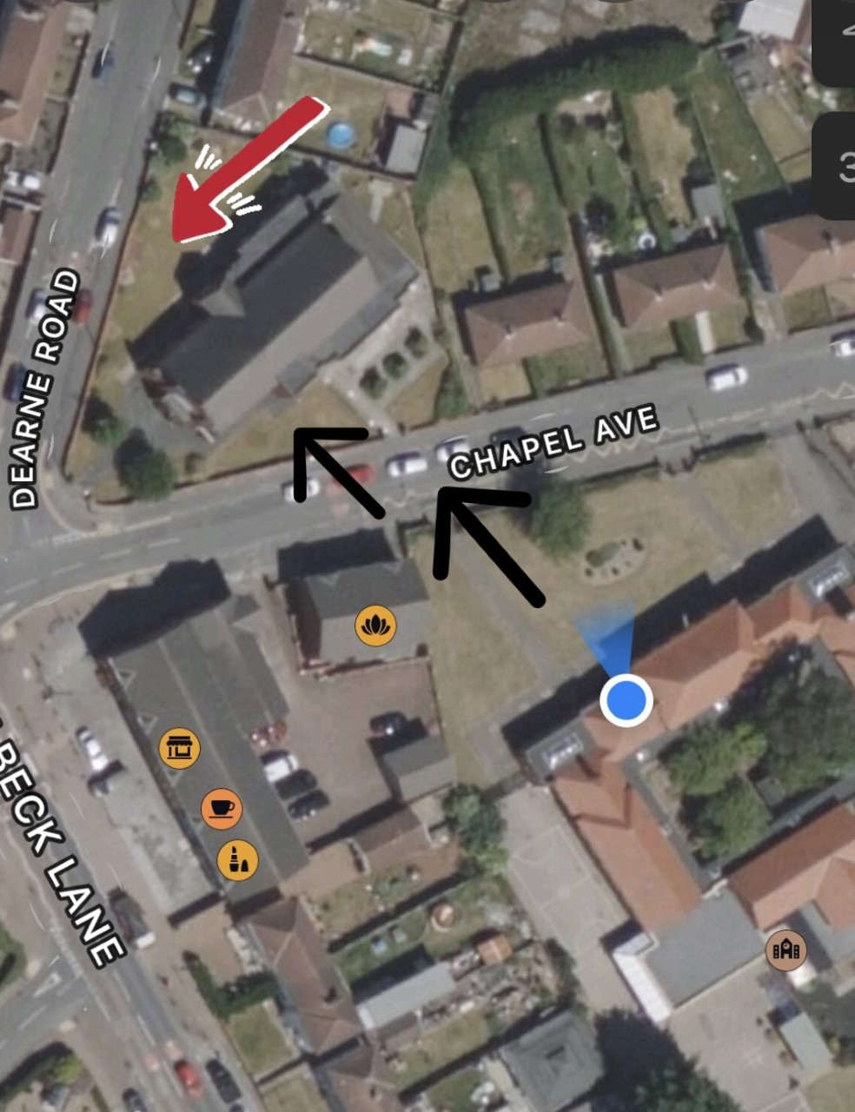

Lockdown Evacuation and Invacuation

Alert to staff: ‘Partial lockdown’ Invacuation

In a partial lockdown staff and pupils should remain in the school building and all doors leading outside should be locked. No one should be allowed to enter or leave the building; however teaching and work can continue as usual. This may be as a result of a reported incident / civil disturbance in the local community with the potential to pose a risk to staff and pupils in the school. It may also be as a result of a warning being received regarding the risk of air pollution etc.
A verbal message will be given to staff confirming that it is an invacuation and not a lockdown and that the following adaptations may happen:
Immediate action

• All outside activity to cease immediately, pupils and staff return to building. (There needs to be a means of communicating the alert to duty staff at break times).
• All staff and pupils remain in building and external doors and windows locked.

• Free movement may be permitted within the building dependent upon circumstances.

• In the event of an air pollution or chemical, biological or radiological contaminants issue, air vents, fans, heating and air conditioning systems should be closed or turned off.

• Use anything to hand to seal up all the cracks around doors and any vents into the room – you aim to minimise possible ingress of pollutants.

• Staff should await further instructions.
All situations are different. Once all staff and pupils are safely inside, senior staff will conduct an ongoing and dynamic risk assessment based on advice from the Emergency Services.
A ‘partial lockdown’ may also be a precautionary measure, but puts the school in a state of readiness (whilst retaining a degree of normality) should the situation escalate.
Emergency Services will advise as to the best course of action in respect of the prevailing threat.

2. Full Lockdown
Alert to staff: ‘Full lockdown’
This signifies an immediate threat to the school and may be an escalation of a partial lockdown. The aim of a full lockdown is for the school and its rooms to appear empty.
Immediate action
• The fire bell will be sounded by 10 short bursts.
• Smarties and F1(F1 teacher to alert F2 teacher) will be called KT/EH, alert them with (Code Red).
• All pupils/staff stay in their classroom or move to the nearest classroom.
• Office staff should remain in their office.
• External doors locked. Classroom doors locked (F1, F2, Y1/2 outside doors), or blocked if no keys/locks.
• Windows locked, blinds drawn, internal door windows covered (so an intruder cannot see in).
• Pupils/staff sit quietly out of sight and where possible in a location that would protect them from gunfire (bullets go through glass, brick, wood and metal. Consider locations behind substantial brickwork or heavy reinforced walls).
• Lights, smartboards and computer monitors turned off.
• Mobile phones turned off (or at the least turned onto silent so they cannot give away your position).
• A register to be taken of all pupils/staff in each classroom/office.
• Staff should await further instructions. SLT will wound the fire bell with 3 short bursts to say the lock down is over. Smarties will be called.
Staff and pupils remain in lock down until it has been lifted by a senior member of staff/emergency services. To ensure children and staff are safe to come out of the lockdown the senior staff will use the password ‘PANDA’ so they know the senior member is not under any duress. This may be used at any point during the lockdown.
During the lockdown, staff will keep agreed lines of communication open but not make unnecessary calls to the central office as this could delay more important communication.
SD / KT/EH will check all external doors are locked and check that there are no children in the toilets.

