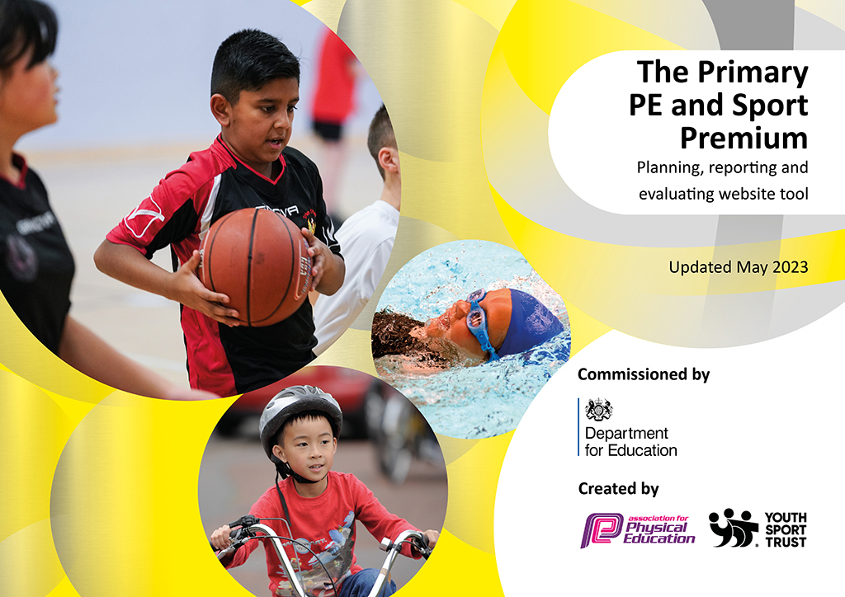
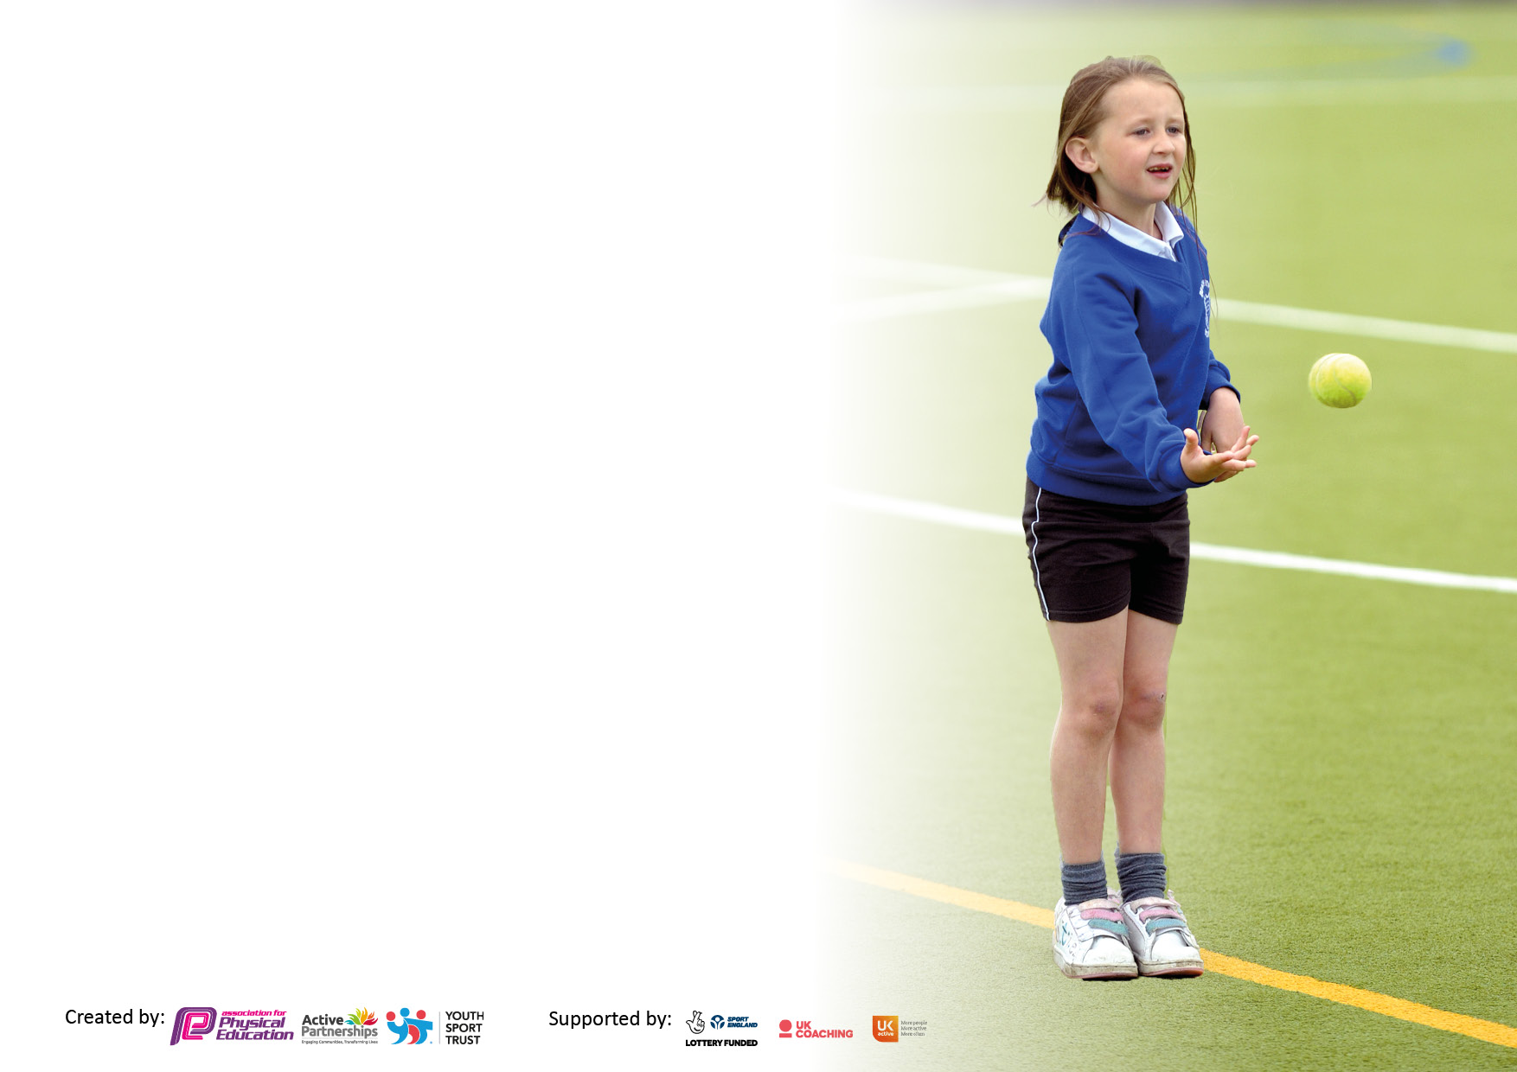

It is important that your grant is used effectively and based on school need. The Education Inspection Framework makes clear there will be a focus on ‘whether leaders and those responsible for governors all understand their respective roles and perform these in a way that enhances the effectiveness of the school’.

Under the Quality of Education Ofsted inspectors consider:
Intent - Curriculum design, coverage and appropriateness
Implementation - Curriculum delivery, Teaching (pedagogy) and Assessment
Impact - Attainment and progress

To assist schools with common transferable language this template has been developed to utilise the same three headings which should make your plans easily transferable between working documents.

Schools must use the funding to make additional and sustainable improvements to the quality of Physical Education, School Sport and Physical Activity (PESSPA) they offer. This means that you should use the Primary PE and sport premium to:

- Develop or add to the PESSPA activities that your school already offer
- Build capacity and capability within the school to ensure that improvements made now will benefit pupils joining the school in future years
- The Primary PE and sport premium should not be used to fund capital spend projects; the school’s budget should fund these.

Pleasevisitgov.ukfortherevisedDfEguidanceincludingthe5keyindicatorsacrosswhichschoolsshoulddemonstrate animprovement.Thisdocumentwillhelpyoutoreviewyourprovisionandtoreportyourspend.DfEencouragesschools to use this template as an effective way of meeting the reporting requirements of the Primary PE and Sport Premium.

We recommend you start by reflecting on the impact of current provision and reviewing the previous spend.

Schools are required to publish details of how they spend this funding, including any under-spend from 2021/2022, as well as on the impact it has on pupils’ PE and sport participation and attainment. All funding must be spent by 31st July 2023.

We recommend regularly updating the table and publishing it on your website throughout the year. This evidences your ongoing self-evaluation of how you are using the funding to secure maximum, sustainable impact. Final copy must be posted on your website by the end of the academic year and no later than the 31st July 2023. To see an example of how to complete the table please click HERE.

Details with regard to funding
Please complete the table below.

Total amount carried over from 2021/22 | £0
Total amount allocated for 2021/22 | £16,830
How much (if any) do you intend to carry over from this total fund into 2022/23? | £0
Total amount allocated for 2022/23 | £16,870
Total amount of funding for 2022/23. To be spent and reported on by 31st July 2023. | £16,870
Swimming Data
Please report on your Swimming Data below.

Meeting national curriculum requirements for swimming and water safety.

N.B. Complete this section to your best ability. For example you might have practised safe self-rescue techniques on dry land which you can then transfer to the pool when school swimming restarts.
Due to exceptional circumstances priority should be given to ensuring that pupils can perform safe self rescue even if they do not fully meet the first two requirements of the NC programme of study
What percentage of your current Year 6 cohort swim competently, confidently and proficiently over a distance of at least 25 metres?  N.B. Even though your pupils may swim in another year please report on their attainment on leaving primary school at the end of the summer term 2022.  Please see note above | N/A
What percentage of your current Year 6 cohort use a range of strokes effectively [for example, front crawl, backstroke and breaststroke]?  Please see note above | N/A
What percentage of your current Year 6 cohort perform safe self-rescue in different water-based situations? | N/A
Schools can choose to use the Primary PE and sport premium to provide additional provision for swimming but this must be for activity over and above the national curriculum requirements. Have you used it in this way? | N/A

Action Plan and Budget Tracking
Capture your intended annual spend against the 5 key indicators. Clarify the success criteria and evidence of impact that you intend to measure to evaluate for pupils today and for the future.

Academic Year: 2022/23 | Total fund allocated: £16,870 | Date Updated: June 2023
Key indicator 1: The engagement of all pupils in regular physical activity – Chief Medical Officers guidelines recommend that primary school pupils undertake at least 30 minutes of physical activity a day in school |  |  |  | Percentage of total allocation:
 |  |  |  | 60.1 % £10,140
Intent | Implementation |  | Impact
Your school focus should be clear what you want the pupils to know and be able to do and about  what they need to learn and to  consolidate through practice: | Make sure your actions to achieve are linked to your intentions: | Funding allocated: | Evidence of impact: what do pupils now know and what can they now do? What has changed?: | Sustainability and suggested next steps:
Children to access weekly PE lessons that are engaging, high quality and teach our children a depth of skills within a range of physical activities.  Sport coaches to work alongside staff to support with the continued development of all staff; in order for staff to feel confident when delivering good-outstanding quality PE provision, both during lessons and at recreational times (playtimes and lunchtimes)  Create opportunities for all children to have an increased awareness of the different types of games they can play at breaktimes and lunchtimes.  To raise the profile of after school clubs by offering a wider range of sporting opportunities for all children.  To increase the variety of resources/equipment available during physical activities.  Children to have access to a wide range of outdoor equipment within weekly taught forest school sessions .  Increase participation within a variety of physical activities during breaktimes and lunchtimes. | Weekly PE coach, directly employed by our academy who will deliver high quality lessons through a range of physical activities. These activities will be focused around, dance, gym, games and athletics. Lessons will be focused on increasing opportunities for skill development linked to our school’s progressive curriculum.  PE coaches will assist and lead on a variety of sporting activities and games, in order to model to staff the most accurate ways for delivering first-quality teaching of physical education both within lessons and recreational times.  Staff to be supported by PE lead through on-going training that develops staff’s knowledge and skills when delivering an engaging and high energy activity, whilst promoting a healthy active lifestyle.  Implement an academic sporting calendar that offers a range of different sporting opportunities, from high energy to precision and skill building. PE lead will monitor clubs through pupil voice to ensure they are successfully meeting all children’s expectations.  Current equipment will be audited and will align to our physical education curriculum. New equipment will be purchased to ensure all areas of our progressive curriculum can be taught successfully.  Yearly checks, adaptations and removal of any outdoor provisions not fit for purpose.  New markings to be applied to the lower playground in order to zone off different sections of the playground, allowing different sports, activities and skill practice to take place during recreational times.  New storage options will be added to the playground to store appropriate equipment linked to that area of the playground ensuring it is accessible and readily available for all children. | £3,000  £1,635  £0  £643  £894  £3,120  £848 | Pupils are benefiting from lessons that they enjoy and make consistent and sustained progress each year. Children have gained a wealth of physical experiences within a range of different sporting activities. Children are able to demonstrate and discuss specific moves, motions and actions required to undertake certain sporting tasks.  Staff have gaining confidence and knowledge within the delivery of their physical education to all pupils thus ensuring all pupils received first quality teaching.  Children have more opportunities to work with different playground supervisors to engage within a wider breath of physical tasks and games. Staff now have the confidence and knowledge to deliver a variety of activities that are exposing children to different forms of physical education.  More children throughout the school year have had access to a wider variety of sporting opportunities. Those opportunities have inspiring children to take up weekend sporting clubs, such as football, wrestling, martial arts, and dance.  Staff now have the resources/equipment needed to teach all areas of our PE curriculum. Children are now able to access a wider range of equipment within a variety of different PE contexts.  Children are confident when using large outdoor climbing equipment, knowing that it is safe and appropriately adapted to meet their needs within PE, forest school lessons, breaktimes and sports day.  All children are able to identify areas within sport that they find interesting and want to pursue further. Children have opportunities over a sustained period of time to practice different sporting tasks/skills and hone their potential. | To continue to access professional coaches to support with the delivery of high quality lessons, as well as providing on-going CPD for staff around implementing all key areas of the national curriculum.  Staff will effectively engage with coaches to improve their own areas of development.  Staff will implement the newly formed assessment tool starting from September, along with the support of coaches to accurately assess pupils strengths and areas of improvement(s).  PE lead to undertake resources audit.  PE lead to continue to train staff linked to new playground routine starting in September 23.  To continue to create a sporting full-year after-school calendar, that offers wider opportunity for children to experience different sporting activities and events.  PE lead will implement a new playground strategy in September that will provide more opportunities for all children to engage within a variety of a higher quality playtime provision/games.  PE lead will continue to monitor all existing equipment and make any necessary adaptation to support all children gross motor skills, when using large equipment.  PE lead will develop a CPD program to support all staff surrounding the expectations for the new playground structure.
Key indicator 2: The profile of PESSPA being raised across the school as a tool for whole school improvement |  |  |  | Percentage of total allocation:
 |  |  |  | 0%
Intent | Implementation |  | Impact
Your school focus should be clear what you want the pupils to know and be able to do and about  what they need to learn and to  consolidate through practice: | Make sure your actions to achieve are linked to your intentions: | Funding allocated: | Evidence of impact: what do pupils now know and what can they now do? What has changed?: | Sustainability and suggested next steps:
To raise and embed the profile of PE and the benefits it can have on children’s positive well-being across the school and wider school community.  To raise the profile and engagement of physical activities and aspirations in all children. | Spots lead to Implement a fixed yearly program of study for all year groups that is in line with the National Curriculum outcomes, whilst delivering our school’s progression curriculum.  Liaise with outside agencies to provide opportunities for an Olympian to visit school. Implement chances for children to meet Jenny Wallwork and experience the training she had to undertake to become a professional. | £0  £0 | All children have Increased fitness through the teaching of a minimum of 2 hours physical education. All children have the knowledge surrounding the importance of health and are able to discuss the benefits that different sporting activities have upon their body.  Staff are clear on the progression of knowledge and skills that all children need to achieve within particular year groups. When observing children, it was clear that skills and knowledge are built upon each year.  PE lead and academy PE lead have undertaken monitoring of the teaching standards in school from school coaches and observed teaching to be good or better.  Children were inspired by the event and have gained knowledge of the different Olympic games. Children have had opportunities to be part of fundraising events that have raised their understanding of the dedication needed to achieve a high level of success within sporting games. | PE lead will continue to monitor coaches and their impact upon class teacher’s delivery of PE.  PE lead will ensure the PE progression model is being effectively implemented throughout school by all staff and coaches . The document will be given to external coaches to allow them to plan their sessions in line with our curriculum.  PE lead to monitor the implementation of the new assessment tool for September 23.  PE lead will work with children and through pupil voice will accurately spend raised funds accordingly.

Key indicator 3: Increased confidence, knowledge and skills of all staff in teaching PE and sport |  |  |  | Percentage of total allocation:
 |  |  |  | 17.7% £3000
Intent | Implementation |  | Impact
Your school focus should be clear | Make sure your actions to | Funding | Evidence of impact: what do | Sustainability and suggested
what you want the pupils to know | achieve are linked to your | allocated: | pupils now know and what | next steps:
and be able to do and about | intentions: |  | can they now do? What has
what they need to learn and to |  |  | changed?:
consolidate through practice:
Support staff through regular up to date knowledge on how to provide good-outstanding PE lessons for all children.  Further develop the school’s PE lead’s knowledge and understanding of the different physical activities offered to all children. | Staff to receive a self-reflective questionnaire to highlight their strengths and areas of improvement and from this, a weekly CPD calendar will be created to best support all staff during their time with the school coaches.  PE lead to access a course in Summer 2 for supporting SEND within PE lessons.  PE lead to accesses courses and support through the academy.  Cover provided when out of class.  PE lead to attend PE JMAT meeting as well as working alongside JMAT coach and sports coordinator from our academy. | £0  £3,000 | Staff have had access to up-to-date CPD, which when speaking to staff they expressed their confidence when teaching all areas of PE  PE lead has effectively collaborated within our wider academy community and has gained skills, knowledge and confidence to allow them to effectively lead PE. PE lead is knowledgeable and skilled at supporting other staff within school, offering training and modelling session outcomes. | PE lead to continue to allocate CPD support where required.  PE lead to continue to assess their own knowledge and skills and access appropriate training.
Key indicator 4: Broader experience of a range of sports and activities offered to all pupils |  |  |  | Percentage of total allocation:
 |  |  |  | 22% £3,700
Intent | Implementation |  | Impact
Your school focus should be clear | Make sure your actions to | Funding | Evidence of impact: what do | Sustainability and suggested
what you want the pupils to know | achieve are linked to your | allocated: | pupils now know and what | next steps:
and be able to do and about | intentions: |  | can they now do? What has
what they need to learn and to |  |  | changed?:
consolidate through practice:
Children to access a high-quality PE curriculum. | External coach to support, deliver and increase the opportunities that all children have within PE by delivering games and functional fitness to all children | £3,700 | Children have had experiences within different competitive team games as well as building their functional fitness skills. When speaking with children they are able to express the practical function of fitness within every day life. | This is to continue in 23/24.

Key indicator 5: Increased participation in competitive sport |  |  |  | Percentage of total allocation:
 |  |  |  | 0.2%
Intent | Implementation |  | Impact
Your school focus should be clear | Make sure your actions to | Funding | Evidence of impact: what do | Sustainability and suggested
what you want the pupils to know | achieve are linked to your | allocated: | pupils now know and what | next steps:
and be able to do and about | intentions: |  | can they now do? What has
what they need to learn and to |  |  | changed?:
consolidate through practice:
All children to take part in competitive sports, learning about the importance of building resilience and being part of a team.  Actively engage children and parents within local community events and school tournaments. | Establish a school culture of competitiveness within all children, through sports day, community events and local and academy tournaments. Raise the profile of celebrating different sporting events through, medals and certificates.  Identify different opportunities for children to take part in our extracurricular tournaments and events within our academy trust to widen their PE experiences by,  developing a calendar of different events, such as:  Shooting stars’ girls football event  Movement evening  Gymnastics festival  Football festival | £30  £100 – School fund  £0 | Children have demonstrated high levels of resilience when competing within competitive sports. Children display team work skills and are keen to continue to better their personal achievements.  PE and physical activities are high profile within school and achievements are shared at a school level and a wider community level thus promoting the importance of PE | PE lead will ensure ther are further opportunities in the next academic year to take part in extracurricular tournaments, festivals and competitions within our academy.  Continue to access these events in 23/24.

Signed off by
Head Teacher: | Mr Shaun Dunkley
Date: | 20.6.23
Subject Leader: | A.McNeill
Date: | 20.6.23
Governor: | Mrs Julie Williams
Date: | 20.6.23

