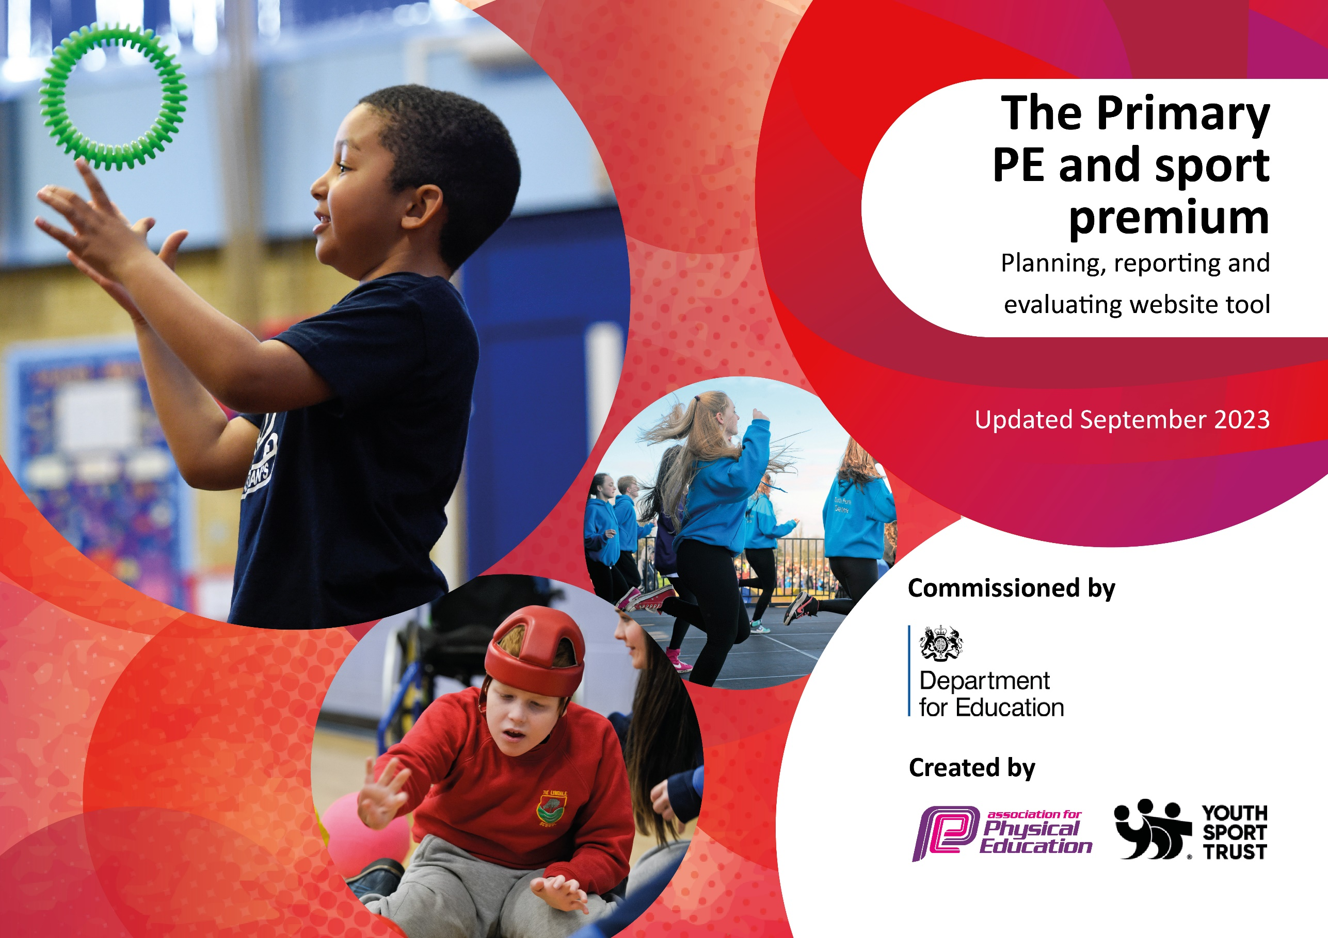

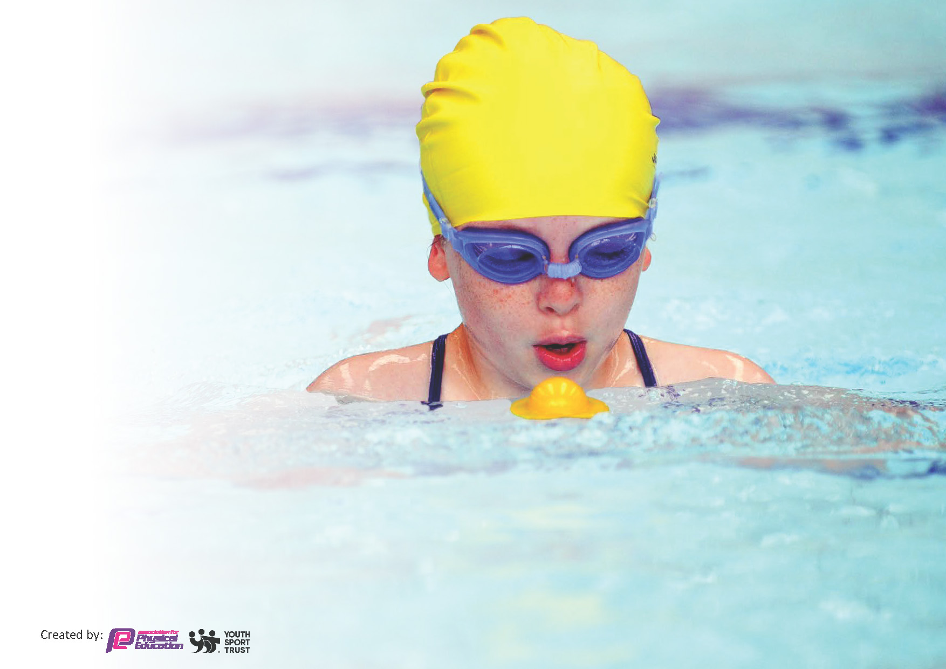
This template can be used for multiple purposes:
by:
- It enables schools to effectively plan their use of the Primary PE and sport premium
- It helps schools to meet the requirements (as set out in guidance) to publish information on their Primary PE and sport premium
- It will be an effective document to support Ofsted inspections enabling schools to evidence progress in Physical Education (PE) and evidence swimming attainment, which forms part of the PE National Curriculum. We would recommend schools consider
the Intent, Implementation and Impact of any spend, as examined within the Education Inspection Framework.

It is important that your grant is used effectively and based on school need.

Schools must use the funding to make additional and sustainable
improvements to the quality of the PE, School Sport and Physical Activity (PESSPA)
they offer. This means that you should use the Primary PE and sport premium to:

- Build capacity and capability within the school to ensure that improvements made now will benefit pupils joining the school in future years
- Develop or add to the PESSPA activities that your school already offers.

The Primary PE and sport premium should not be used to fund capital spend projects; the school’s core budget should fund these. Further detail on capital expenditure can be found in the updated Primary PE and sport premium guidance.

The Primary PE and sport premium guidance, outlines 5 key priorities that funding should be used towards. It is not

necessary that spending has to meet all the key priorities, you should select the priorities that you aim to use any funding towards.

Although completing this template is not a requirement for schools, schools are required to publish details of how they spend this funding. Schools must also outline what the impact this funding has had on pupils’ PE and sport participation and attainment and how any spending will be sustainable in the future. All funding must be spent by 31st July 2024.

The Department for Education has worked closely with the Association for Physical Education (afPE) and the Youth Sport Trust (YST) to develop this template and encourages schools to use it. This template is an effective way of meeting the reporting requirements of the Primary PE and sport premium.
Review of last year’s spend and key achievements (2022/2023)

We recommend you start by reflecting on the impact of current provision and reviewing your previous spend.

Activity/Action | Impact | Comments
Auditing and purchasing of equipment  Coaches | Children have access in EYFS and KS1 to a wide range of PE resources for both PE lessons and active playtime and lunchtimes.  Our working with coaches is still successful and is providing our children with a well balanced and high quality PE education.

Key priorities and Planning
This planning template will allow schools to accurately plan their spending.

Action – what are you planning to do | Who does this action impact? | Key indicator to meet | Impacts and how sustainability will be achieved? | Cost linked to the action
We want our children to have access to a high quality and broad PE curriculum.  We want the PE lead to gain knowledge and be upskilled.  We want our children to access PE lessons that are engaging, high quality and allow our children to practice and improve on their PE skills.  We want our sport coaches to work alongside staff to support high quality PE provision both in lessons and at playtimes and lunchtimes.  We want our children to have an increased awareness of the games they can play at break and lunchtimes and are given support for this.  We want our children to access outdoor equipment in our forest school areas safely on a weekly basis.  We want all our children to have access to high quality equipment.  We want to raise the engagement of physical activities and aspirations in our children.  We want staff to feel they are supported and have up to date knowledge on how to provide the best PE lessons to the children.  We want to engage pupils and parents within local community events involving taking part in school-on-school tournaments.  We want our children to take part in competitive sports, learning about the importance of building resilience and being part of a team.  We are aiming for more structure and variety within our playtimes with the access to appropriate storage.  We want to raise the profile of after school clubs and offer a range of sporting clubs for all children. | Coach Nathan to support, deliver and increase opportunities for skill development linked to our curriculum, within high quality PE lessons.  PE lead accesses courses and support through our academy.  Cover is provided when out of class.  PE lead attended PE JMAT meeting as well as working alongside JMAT coach and Sports coordinator for our academy.  PE coach for JMAT to provide support, deliver and increase opportunities for skill development linked to our curriculum.  To also provide support to our ECTs we have had in school.  PE coach also assists and leads active lunchtimes once a week as well as providing support to other staff.  Playground supervisors to encourage and promote a healthy active lifestyle.  Yearly outdoor climbing equipment check.  Removal and replacement of unsafe equipment.  Equipment audited and purchased.  Football score fundraiser.  Children fundraised money for school and for the organisation.  Staff to access weekly coaches’ lessons as CPD.  Children to take part in our extracurricular tournaments and events within our academy trust.  Children have had access to attend these different events:  Shooting stars’ girls football event  Movement evening  Gymnastics festival  Football festival  Children to take part in sports day.  Sports day medals purchased to celebrate achievements.  New storage containers will be added to the playground to keep equipment more accessible to children.  Implementing a balanced after-school sporting program of study. All clubs to be monitored to ensure they are successfully delivered and received all year-round.  Mini Kixx - all year round F2-Y2  Movement evening – Autumn 2/ Spring 1 | Key indicator 4: Broader experience of a range of sports and activities offered to all pupils  Key indicator 3: Increased confidence, knowledge and skills of all staff in teaching PE and sport.  Key indicator 1: The engagement of all pupils in regular physical activity – Chief Medical Officers guidelines recommend that primary school pupils undertake at least 30 minutes of physical activity a day in school  Key indicator 1: The engagement of all pupils in regular physical activity – Chief Medical Officers guidelines recommend that primary school pupils undertake at least 30 minutes of physical activity a day in school  Key indicator 1: The engagement of all pupils in regular physical activity – Chief Medical Officers guidelines recommend that primary school pupils undertake at least 30 minutes of physical activity a day in school  Key indicator 1: The engagement of all pupils in regular physical activity – Chief Medical Officers guidelines recommend that primary school pupils undertake at least 30 minutes of physical activity a day in school  Key indicator 2: The profile of PESSPA being raised across the school as a tool for whole school improvement  Key indicator 3: Increased confidence, knowledge and skills of all staff in teaching PE and sport  Key indicator 5: Increased participation in competitive sport  Key indicator 5: Increased participation in competitive sport  Key indicator 1: The engagement of all pupils in regular physical activity – Chief Medical Officers guidelines recommend that primary school pupils undertake at least 30 minutes of physical activity a day in school  Key indicator 1: The engagement of all pupils in regular physical activity – Chief Medical Officers guidelines recommend that primary school pupils undertake at least 30 minutes of physical activity a day in school | Children are highly involved in Coach Nathans lessons and he provides a broad experience of PE lessons as well as following our school curriculum.  PE lead has collaborated more within our academy and is continuing to upskill herself, providing her with the knowledge and skills needed to support other staff and cascade appropriate training to teaching staff.  Pupils are benefiting from lessons that they enjoy and make consistent and sustained progress each year.  Staff are gaining confidence and developing their ability to teach high quality PE.  Children are more actively engaged at playtimes and are using equipment more.  Children are continuing to use safe and appropriate resources in PE lessons, breaktimes and sports day.  The outdoor climbing equipment passed its safety check so now all children can carry on using it safely.  Children have access to a range of equipment in PE lessons and active playtimes.  Children were engaged and loved being part of the football fundraiser.  Staff have access to up-to-date CPD, which has developed their knowledge, skills and confidence when teaching all areas of PE  There has been more of a celebration of skills from taking part in the academy wide competitions and festivals.  Movement evening was successful and aspirational to those who took part, it offered a wider experience within PE for children who may not receive these experiences in their home life.  Children who have attended these events have had the opportunity to work as a team and against others schools.  Training and clear expectations will be given to staff and children in September for the new playground structure.  Many children have accessed these clubs. Mini Kixx has been very popular every half term and has exposed children to a wider variety of sports. | £3,700  £3000  £3000  £3994.6  £445.00  £234.85  £0  £0  £0  £5.16  £2,450.97  £0

Key achievements 2023-2024
This template will be completed at the end of the academic year and will showcase the key achievements schools have made with their Primary PE and sport premium spending.

Activity/Action | Impact | Comments
After school clubs  JMAT academy sports events  Staff accessing CPD PE lessons from coaches | Our children that have accessed after school clubs have been highly engaged and we have has a large uptake of children wanting to take part.  Children who have taken part have enjoyed having accesses to different sporting festivals and competitions. The girls football festival had a fantastic uptake and inspired many girls to take part.  Our teachers have had access to all PE lessons this year that have been used to upskill ourselves. Our JMAT coach has worked with two of our ECT’s in supporting and developing their teaching and assessment of PE.

Swimming Data
Meeting National Curriculum requirements for swimming and water safety.
Priority should always be given to ensuring that pupils can perform safe self-rescue even if they do not fully meet the first two requirements of the National Curriculum programme of study

Question | Stats: | Further context  Relative to local challenges
What percentage of your current Year 6 cohort can swim competently, confidently and proficiently over a distance of at least 25 metres? | % | Not applicable as we are an infant school.
What percentage of your current Year 6 cohort can use a range of strokes effectively [for example, front crawl, backstroke, and breaststroke]? | % | Not applicable as we are an infant school.

What percentage of your current Year 6 cohort are able to perform safe self-rescue in different water-based situations? | % | Not applicable as we are an infant school.
If your schools swimming data is below national expectation, you can choose to use the Primary PE and sport premium to provide additional top-up sessions for those pupils that did not meet National Curriculum  requirements after the completion of core lessons. Have you done this? | Yes/No | Not applicable as we are an infant school.
Have you provided CPD to improve the knowledge and confidence of staff to be able to teach swimming and water safety? | Yes/No | Not applicable as we are an infant school.

Signed off by:

Head Teacher: | Mrs V Lambert
Subject Leader or the individual responsible for the Primary PE and sport premium: | A.McNeill
Governor: | George Dowson
Date: | 17.7.24

