**Address:**

Brampton Cortonwood Infant School

Chapel Avenue

Barnsley

S73 0XH

**Brampton Cortonwood Infant and Nursery School**

**Prospectus**

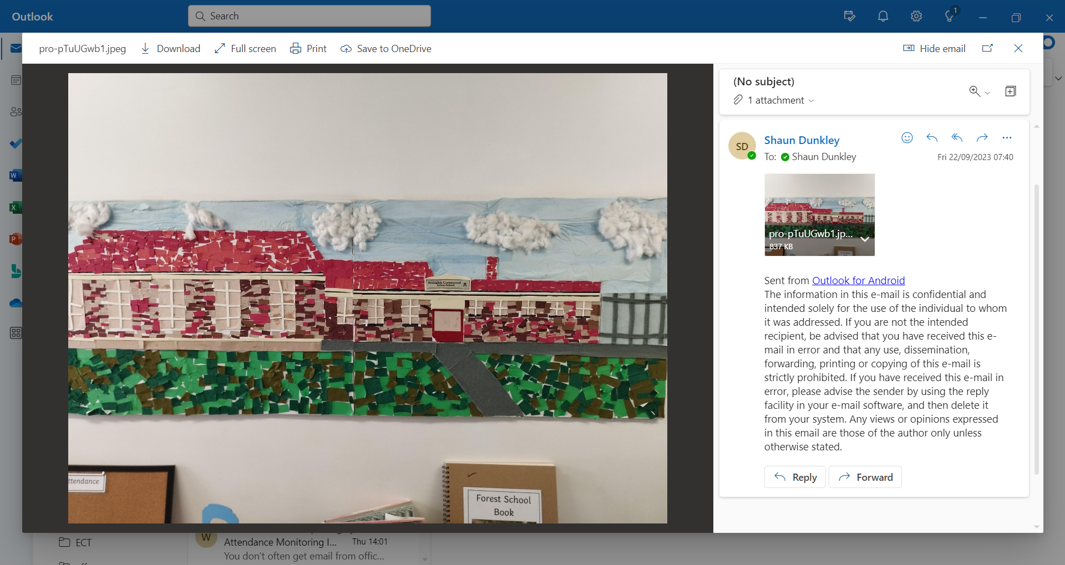



This pack contains key information for parents about their child starting Brampton Cortonwood Infant and Nursery School

Please contact us if you have any further questions or queries.

Mr S Dyson

Head of School

Brampton Cortonwood Infant School

At Brampton Cortonwood we are passionate about delivering a curious, creative and ambitious curriculum that is purposeful and relevant to our children and their needs. Our curriculum is centered around a Forest School ethos and designed to allow all children to...

BELIEVE, ACHIEVE, SUCCEED!

Our curriculum has been designed using the national curriculum as a starting point. We have then built our own curriculum making sure it is relevant in meeting the needs of our community, whilst matched appropriately to the age, maturity and knowledge of our children. We have carefully sequenced the content to ensure a progressive model is in place that is balanced, coherent and focused. We understand the need to continually review our curriculum to ensure that it is always fit for purpose in meeting the learning needs of our children.

Each half term, we have a whole-school theme that the children's learning will be based around. Within each theme, each year group will have a sequential topic that builds on the learning and experiences from the previous year group. Our curriculum is built around essential knowledge and the importance of teaching vocabulary so our children are able to learn and understand more about things outside of their daily experience.

Alongside our curriculum, and intrinsic to its success, are the Brampton Cortonwood 'Green Family Values.' These define the qualities and attributes that our children aspire towards. These family values also include our conduct behaviours focusing on consistency and high expectations.   
**Meet our Green Family:**

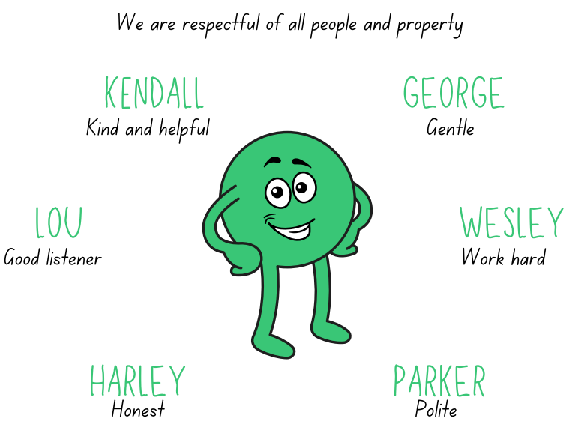

This enables our children to become:  
RESILIENT REGULATED RESPECTFUL



## **General Information about Brampton Cortonwood Infant School**

Chapel Avenue

Brampton Bierlow

Wombwell

Barnsley

S73 0XH

Tel: 01226 340044

* Email: school@bc.jmat.org.uk
* Website: www.bramptoncortonwoodinfants.co.uk

Head of School: Mr S Dyson

We are happy that you have chosen our school to be involved with the education and development of your child. We trust that this will be the start of a long and successful partnership.

* Mr Dyson is Brampton Cortonwood’s Head of School from September 2021 and he, with the Governing Body, has overall responsibility for the school. They are supported by teaching staff, dinner supervisors, administrative staff, caretaker and cleaning staff.
* Our Telephone number is: 01226 340044 and will connect you to the school office or the school answer machine.
* As an Infant school, we deliver the Early Years Foundation Stage Curriculum (2 to 5 years) and the Key Stage 1 Curriculum (5 to 7 years).
* The school is open from 8:30am, where children will be dropped off at a designated door (8.45am for Smarties and F1).
* Lunchtimes in school are between 11:45pm – 1:15pm and school closes at 3:00pm (2.45pm for Smarties and F1).
* Your child will be provided with a school meal. This is free of charge from Foundation 2 upwards and menus are on display outside each classroom. Parents can choose to opt out by providing a packed lunch for their child.
* There may be occasions when emergencies make it necessary for pupils to be sent home prematurely e.g. illness/snow disruption. In these circumstances it would be useful to have arrangements in place.

Arrival and Departure

Your child will be met at their designated door by their teacher on arrival. You must let us know if a different person will be collecting your child. Please inform the office if there is a change to this, or if someone else is collecting your child on your behalf. You will need to let the office know this in advance and provide us with their name. We will not permit a child to leave the premises unaccompanied or unsupervised.

Late Collection or Failure to Collect

You must notify us as soon as possible if you will be late to collect your child – this helps reduce the stress on the child.

If after closing time your child has not been collected, we will make every attempt to contact you on all of the numbers you have provided, including the Emergency Contact numbers. Our policy states that if after one hour, if all reasonable attempts to contact parent/carers have failed then the school will contact the relevant social services departments as per our Safeguarding Procedure.

Uniform

We believe that wearing a uniform promotes a feeling of community and team spirit amongst our children and can give them a sense of belonging, promoting all of our school values. Whilst we ask that children wear school uniform, we also ask that children are dressed appropriately for the weather and have a change of clothes with them in a backpack. The school has a dress code: white polo shirt or blouse, grey or black trousers/ skirts, blue sweatshirt/ cardigan, leggings/tights and black shoes. Items of uniform incorporating our school logo can be viewed at the school office, however are not essential. All clothes should be clearly marked with the child’s name. Children should have a PE kit in school consisting of shorts, T-shirt and foot wear. Tracksuit bottoms and a tracksuit top will be need during the colder months. Leotards can also be worn.

Children are not permitted to wear jewellery for safety and security reasons. Plain stud earrings are permitted but must be removed for PE.

On Forest School days, children can come in old, warm clothing and bring their school clothes to put on after the session. Children will access our outdoor area in all weathers unless it has been deemed as unsafe.

Children will need a **backpack** suitable for outdoors that they can carry.

**what to wear in SPRING/Autumn**

* School uniform
* Comfortable trousers such as jogging bottoms or leggings
* A long sleeved t-shirt or thin jumper
* A waterproof coat
* Closed toe shoes or wellies (which you don't mind getting wet and muddy)
* Spare trousers/leggings & socks in backpack (more than one set of each plus underwear if toilet training)
* Waterproofs on Forest School days (we have a small number that can be borrowed if required)

**What to wear in summer**

* School uniform
* Comfortable trousers such as jogging bottoms, leggings, dresses or shorts
* A short/long sleeved t-shirt or thin jumper
* Waterproof coat
* Closed toed shoes, wellies (which you don't mind getting wet and muddy)
* A sun hat
* Spare clothes & socks in backpack (more than one set of each plus underwear if toilet training)
* Waterproofs for Forest School days

**What to wear in winter**

* School uniform
* Warm hat
* Gloves – fleece lined waterproof gloves or mittens with a pair of “magic gloves” underneath work well and help keep the children's hands extra warm
* One or two pairs of socks – a thin pair of cotton socks topped with a thick wool/thermal/fluffy pair of socks
* Snow boots– If wearing wellies please send extra socks.
* Spare clothes (in backpack) – (more than one set of spare trousers plus underwear if toilet training)
* Waterproofs and extra layers for Forest School days.

Food and Drink

Milk/water and healthy snacks are available throughout your child’s school day. Children are encouraged to bring their own water bottle to school.

Dinners & Free School Meals

All Infant school children are entitled to a universal free school dinner. However, you may also be entitled to Free School Meals (FSM) if your household is on a low income. Applying for this means you will also qualify for additional funding in school. To apply for FSM please see the following web address.

<https://www.rotherham.gov.uk/benefits/apply-free-school-meals>

A copy of the dinner menu will be provided on Dojo and the website each term. You may also send a healthy packed lunch for your child. Parents are responsible for providing food their child will eat and the utensils required. In warm weather, parents may want to include a cool pack in the lunch box.

**Packed Lunch –** the possibilities are endless but here are some suggestions…

* Baguette/ bagel/ ciabatta/ wrap/ sliced/ wholegrain/ bread roll/ pitta pocket… with salad and favourite filling
* Hummus tub and vegetable sticks
* Sausage roll or vegetarian alternative
* Cooked pasta/ couscous/ rice/ quinoa (make a large batch and use a little each day, add flavour with sauces and vegetables)

**We have children in school with a nut allergy, so please do not send in any foods containing nuts – including: packs of nuts, nut butter spreads e.g. peanut butter, Nutella, or fruit and cereal (muesli) bars that contain nuts etc.**

**Children are reminded and carefully supervised to minimise the act of food sharing with their friends. They are also taught good hygiene practices such as washing hands before and after eating to help reduce the risk of secondary contamination.**

**Please indicate on the Registration Forms if your child has any food allergies or special dietary requirements.**

Payments

We are a ‘cashless school’ and currently operate an online payment system called ‘School Money’. Any payments for uniform, educational visits and after school clubs etc. can be made online or by card payment at the school office.

Attendance

Regular attendance is vital if children are to achieve their potential. It is the responsibility of parents to ensure that children attend regularly and make the most of the educational opportunities provided. Attendance will be monitored by the school. Please see the Attendance Policy on the school website or ask for a paper copy from the school office. The policy includes information about late gate and attendance panel meetings. We also have a reward system in place for the classes that meet our attendance target each week. If your child is absent from school, you MUST contact the office to inform us why they are absent.

Medication and Illness

We will only administer medication that has been prescribed by your child’s doctor, dentist, nurse or pharmacist. The medication must be in the original packaging and have your child’s name and dose clearly on the container. You will need to complete our Medication Form with the office staff before staff will administer any medication. When medication is administered at school, it will be recorded on the form. Ideally all medicines should be administered by the child’s parents.

If your child has regular medication – for example an inhaler for asthma - you must ensure it is handed over to a member of staff and ideally a separate inhaler should always be kept in school. A separate form will be completed for this purpose. If your child does not have their regular medication with them, they may be unable to attend.

If your child has more complex medical needs, we will work closely with you and health professionals involved in your child’s care to ensure we meet their needs fully.

* **Diarrhoea and Sickness**: Any child who is ill with diarrhoea and / or sickness must have 48 hours clear before returning to school.
* **Head lice** are a recurring problem in schools. We’d ask that you check your child’s hair daily when combing.
* The treatment for head lice should be administered at home before the child returns to school.
* **Prescribed Medication**: Any medication (apart from asthma treatment) which involves the taking of **4** doses **must** be administered by the parent/carer during the lunch break or at a mutually convenient time. In some circumstances staff may administer medication. This must be **prescription only**, not over the counter medication.
* **Long Term Illnesses or Medical Conditions**: Contact the office and an appropriate care plan will be put in place

Admissions

If you wish your child to attend our school, you need to:

* Contact the school Tel: 01226 340044.
* Please see our Admissions Policy on the school website.

Early Years Foundation Stage

At Brampton Cortonwood Infant School, we work hard to provide high quality care and education for our children through the creation of a safe, stimulating and happy learning environment. We strive to offer a warm welcome to each individual child and family. Meeting your child’s individual needs is our priority and we will work in partnership with you to ensure we achieve this.

Learning in the Early Years Foundation Stage is a unique and exciting time for your child to discover their potential and spark their enthusiasm for learning. We are thrilled to welcome you all into our BCI family.

Smarties and Foundation 1

We want your child to feel happy and safe with us. We offer two initial (shorter) “settling-in” sessions that give us the opportunity to meet you and your child and begin to build positive relationships. Some children settle quickly, others require more time. You may feel ready to leave them for a short period or you may wish to stay with them. We will work with you to decide how best to settle your child - there are no expectations or rules about this. Staff will be guided by you and support you with this. We are happy to listen to your views and ideas and to answer any questions.

As we are a small preschool and Foundation 1 class, all the adults will be part of your child's experience, however your child will be assigned a member of staff as their 'key person'. You will be introduced to your child’s key person; they will be responsible for supporting your child, sharing information with you about your child’s learning and supporting any concerns you may have or specific needs as they arise.

All staff have Enhanced Disclosure and Barring (DBS) checks and are experienced in working with children. The Lead Practitioner or an equivalent level 3 practitioner are in charge and are present at all sessions. Staff are trained in early years childcare and are qualified in Paediatric First Aid. We operate on a ratio of 1 adult: 8 children for three-year olds and 1 adult : 5 children for two-year olds. We are term time only and are open from 8.45am-2.45pm- Monday- Friday. **In the very unlikely event that we do not have enough staff to maintain ratios we will contact you to cancel the session.**

Session Times

Our sessions run from 8:45am to 11:45am and 11:45am to 2:45pm. At this time, we offer a minimum of 15hrs across either the morning sessions or afternoon sessions. We can only offer specific sessions or full days if we have been unable to fill these sessions.

Fees

For 2-year olds, we charge £22.35 per session, £111.60 per week (5 sessions). For 3-year olds, we charge £14.61 per session £73.05 per week (5 sessions). Children must access either all AM or all PM sessions. We can only offer flexibility on this if spaces are available. Priority will be given to children accessing 15 hours then 30 hours.

Fees are payable monthly in advance and must be paid before your child attends on the first day of each month. Fees must still be paid if children are absent for a short period of time including holiday and illness. If your child is likely to be absent for a long period of time, please talk to our School Business Manager, Julie Fenton. For your child to keep their place, you must pay the fees. Fees will still be charged if you take a holiday in term time.

Funding

Some parents are eligible for funding for 2 and 3-year-old places. Visit [www.gov.uk](http://www.gov.uk) to check if you are eligible for funding. If you are eligible for funding, you will be able to apply for a code from the above website. We can offer you support with this. Please contact our school office.

Parental Involvement

There are many ways in which you can participate in your child’s learning including:

* + Sharing knowledge of your child’s needs, activities and interests with staff.
  + Talking to your child about their day, what they have done and what they have enjoyed.
  + Encouraging your child to become more independent at home, provide opportunity for them to practice dressing themselves for example.
  + Sharing your own interests with your child.
  + Ensuring your child is dressed appropriately.
  + Participate in community activities and events organised by school.
  + Building friendships with other parents at the school.
  + Accessing our school’s Dojo page and your child’s class Dojo page to help keep you updated with events happening at school.

As a parent/carer, you are welcome to visit us any time. Please see a member of staff to make a mutually convenient time. You will also be invited to a parent meeting to discuss your child’s development.

Toileting

Children in nappies are changed regularly in our changing area. Parents/carers provide their own supply of nappies, wipes or cotton wool for their child. We encourage the children to be as independent as possible while still providing supervision and support. If you are thinking of starting toilet training with your child, make a member of staff aware so that we can support you and your child.

Foundation 2

We want your child to feel secure and happy within our Foundation 2 class. If your child is new to our school, or you feel that they may need support with transition, then we will work with you to decide how best to settle your child - there are no expectations or rules around this. We are happy to listen to your views and ideas and to answer any questions. The teachers, or an equivalent level 3 practitioner, are in charge and present at all sessions. Staff are trained in early years childcare and are qualified in First Aid or Paediatric First Aid. All the adults in your child’s class will be part of your child's experience, however your child will be assigned a member of staff as their 'key person'. Your child’s key person plays a large role in supporting your child, sharing information with you about your child’s learning and supporting any concerns you may have, or specific needs as they arise.

Session Times

Our school day runs from 8:30am to 3:00pm and your child will be provided with a free lunch.

Learning and Development within EYFS

In the Early Years Foundation Stage (EYFS) we follow the EYFS Framework to ensure we provide children with a broad range of knowledge, skills and experiences. Much of our learning is child-led and play-based; we plan half termly following the children’s interests. We encourage the children to develop their own ideas, think critically and creatively and become motivated by their own learning. We also provide adult-planned learning experiences throughout the week. They may be based on specific interests expressed by the child or designed to develop specific skills. We provide a range of open-ended resources which children can access and make full use of the resources found in our indoor and outdoor environment.

Assessment during EYFS

All our assessment is carried out through observation and discussion; it is non-obtrusive, informal and on-going. We use this assessment to document your child’s progress, identify next steps to move the learning on and to help us plan further learning opportunities. We share this information with you regularly and we also ask you to contribute to this by sharing information about what your child enjoys doing at home – this helps form the bigger picture of your child’s learning experience. As required by the Government, we carry out a baseline assessment during the first six weeks of F2. This is an activity-based assessment of pupils’ ability in:

* language, communication and literacy
* mathematics

Key Stage 1

Once your child has progressed through our early years classes they will move into Key Stage 1 that comprises of Year 1 and Year 2 classes.

Key stage 1 builds on your child’s prior knowledge and skills form EYFS progressing them onto the Key Stage 1 National Curriculum.

Learning and Assessment

Your child will experience a broad and balanced curriculum that follows all of the subject areas outlined within the National Curriculum. Children will be assessed against all subject areas and assessments will be undertaken through hands on tasks that allow all children to display their skills and knowledge in different ways.

Reading and Phonics at Brampton School

Learning to read is one of the most important skills that your child will develop over the next few years at Brampton Cortonwood Infant School. The more support and encouragement that you can offer your child, the more likely that he or she will progress with enthusiasm and ease.

At Brampton Cortonwood Infant School we are committed to the delivery of excellence in the teaching of Phonics. We aim to develop each child so that they are able to read with fluency as well as develop a love of reading that will stay with them for the rest of their life.

We use the systematic and structured Phonics Programme Floppy’s Phonics that is in line with the principles described in the ‘English programmes of study, for Early Years and Key Stage 1, which was statutory from September 2014. Not all words in the English language comply to the rules of phonics so we also teach so-called ‘sight words’ and ‘common exception words’ by repetition, retrieval and emphasising which parts of the word doesn’t comply to the rule of phonics so that children are able to build an attached memory to those words. This will aid with fluency and speed when children are reading.

Phonics

The Floppy’s Phonics programme teaches the letter/s-sound correspondences of the English alphabetic code explicitly and comprehensively for reading and spelling. It includes the characters of Floppy the dog, Biff, Chip and Kipper and their family and friends, which engages children fully for the phonics teaching & learning, vocabulary enrichment and language comprehension.

Initially children's listening skills are developed through the use of music, environmental sounds and rhyme within Nursery. During their journey through the Early Years Foundation Stage and Key Stage 1 they are taught the 44 phonemes (sounds) that make up all the sounds required for reading and spelling. These phonemes include those made by just one letter e.g., 'b as in bed' and those that are made by two letters e.g., 'ai as in rain or three letters e.g., 'igh as in high'.

Children are taught the key skills of segmenting and blending sounds together for reading. They are taught to use their segmenting skills (breaking up) words for spelling.

As the children grow in confidence and experience, they are introduced to alternative ways of representing the same sound, e.g., 'ee' can be represented as 'ee as in bee', 'ea as in tea', 'e-e as in theme' and 'e as in we'. They also learn when to apply simple spelling rules and use verbs in the correct tense.

We ensure that our teaching of phonics is rigorous, structured and enjoyable. In Reception to Year 2, children have discrete, daily mixed phonics sessions that are bespoke to each child’s needs. During these sessions, emphasis is placed on revising a previously learned letter-sound correspondence, learning a new one, practising this within reading, writing and spelling, and applying it within a relevant context such as reading text and/or writing sentences. Children are given plenty of opportunities to apply the knowledge they have learnt into reading, writing and spelling within the wider school curriculum.

We use a range of multisensory strategies to enthuse and engage the children, including the use of interactive whiteboards, books, flash cards, magnetic letters, grapheme tiles, speaking and listening games, and practical activities. Children work with pace and vigour and are encouraged to apply their learnt knowledge across the breadth and depth of the school’s custom-made curriculum.

Reading

Brampton Cortonwood Infant School gives high priority to reading, our children are exposed to a range of high quality texts, and there are areas around school where children are encouraged to enjoy reading for pleasure. All children visit the school library weekly and choose a book that they are interested in. This may be a book that they are able to read independently or a book that can be enjoyed with parent support. When children are able to blend they have access to individually levelled phonically decodable online reading books at home and in school, the children also have a school reading book that is a phonically decodable book that matches their Floppy’s Phonics reading level. Once a child has completed a Floppy’s Phonics reading level, they are able to select a book from the appropriate book band level that matches their own reading level. All children read during Floppy’s Phonics sessions and are individually heard read at least once a week by a member of staff

In Years 1 and 2, children have guided reading sessions five times a week with a focus on comprehension. Children are asked to answer questions from the five reading domains.

In F1, our children’s reading journey begins with Guided Talk sessions. This involves the children using wordless picture books to practise key skills like how to hold a book and turn a page and how to track from left to right when looking at the sequence of pictures. In these sessions, the children talk about what they can see, with an adult, and share their thoughts and opinions about what they think might be happening in the story.

In F2, at the appropriate point within the Autumn or Spring term based on the cohort’s current reading ability, the children begin group guided reading sessions. These sessions focus on comprehension with an element of phonic decoding as appropriate. This also is an opportunity for children to be exposed to their ‘sight words’ which they are encouraged to spot within the text they are reading.

Quality story sessions are timetabled in daily and there is an emphasis on developing a love of books, vocabulary and understanding, which is evident within classroom reading areas that display specific class texts and a book of the week.

We want all our children to be fluent readers –regardless of their starting point and barriers to learning. For those children identified as working below the expected standard in reading, the school provides further support in various ways. Such as, offering ‘keep up’ sessions to encourage reluctant readers to engage with reading and ‘catch up’ sessions alongside key staff who are trained to delivering a Floppy’s Phonics ‘catch up’ programme tailored to meeting the specific needs of those children requiring such a programme.

Behaviour and Rewards

We aim to provide a happy and secure environment for all those who work in or visit our school.

The core element of our ethos is positivity. Having unconditional positive regard for all pupils is the driving force in supporting the range needs presented by our pupils. At Brampton Cortonwood we recognise that behaviour is driven by feelings and displays of negative behaviour are often a result of the child being unable to identify, understand and communicate those feelings. We aim to provide a safe, nurturing environment that is built on warmth, understanding and trust so our pupils can be supported in self-regulation and managing their feelings to achieve positive behaviour.

Safeguarding

Brampton Cortonwood fully recognises its responsibilities for safeguarding and child protection. We know that children learn best when they are healthy, safe and secure, when their individual needs are met, and when they have positive relationships with the adults caring for them. Our school provides a natural learning environment that is safe and stimulating and where children are able to enjoy learning and grow in confidence.

• We work with children, parents, external agencies and the community to ensure the welfare and safety of children and to give them the very best start in life. Children have the right to be treated with respect, to be helped to thrive and to be safe from abuse in whatever form.

• We support the children within our care, protect them from maltreatment and have robust procedures in place to prevent the impairment of children’s health and development. In our school we strive to protect children from the risk of radicalisation, and work hard to promote acceptance and tolerance of other beliefs and cultures.

The Designated Safeguarding Lead is the Head of school, Mr S Dyson. If you have a concern that a child is being harmed, is at risk of harm, or any child makes a disclosure to you, you must report it to the Designated Safeguarding Lead as soon as possible. If the concern relates to a member of staff, you must report it to the Designated Safeguarding Lead who will contact the Local Authority Designated Officer (LADO).

If the concern relates to the Designated Safeguarding Lead or the Designated Safeguarding Lead is unavailable, you must contact the Deputy Safeguarding Leads, Mrs Levitt (Early Years Lead) or Mrs Preece (HLTA).

The Governing Body

The Governing Body ‘Federation’

The Governing board is a federation between Brampton Cortonwood and Brampton Ellis. They meet at least once a term and are responsible for the general running of the school, the curriculum, school budget, appointment of staff, maintenance of buildings and school policies, such as discipline, Health and Safety, RE, Inclusion policy etc. The Governors also undertake training when specific issues are being developed. Parent governors are committed and are regularly involved in the life of the school.

**The Governing Body consists of:**

|  |  |
| --- | --- |
| **Name** | **Governor** |
| Mrs J Williams | Chair and SEND |
| Mrs E Nutley | Co-opted Governor and Safeguarding Governor |
| Mr S Dyson | Head of School |
| Mrs C Steeple | Staff Governor |
| Mrs K White | Co-opted Governor |
| Mr G Dowson | Parent Governor – Vice Chair |
| Miss J Stevenson | Staff Governor |
| Mr L Bell | Parent Governor |

**School Staff**

**Teaching Staff**

Mrs A Benbow Federation Head

Mr S Dyson Head of School

Mrs T Levitt Foundation Stage Leader / Teacher and SENCo

Miss H Stewart KS1 Teacher

Miss A McNeill F2/KS1 Teacher

Miss M Roome KS1 Teacher

Mrs C Steeple FS1 Teacher

**HLTA and Safeguarding**

Mrs L Preece

**Teaching Assistants**

Mrs V Spencer FS1

Miss L Tadajewski FS1

Mrs A Studd EYFS

Mrs J Balint Pratt KS1

Mr M Savage KS1

Mrs J Willis EYFS

Mrs A Jessop KS1

Mrs K Rogers EYFS

**Early Years Practitioners**

Mrs M Frost EYFS Teacher

Mrs J Hopkinson EYFS Practitioner

**School Business Manager**

Miss J Fenton

**Administrative Assistants**

Mrs K Taylor Mrs E Hirst

**Caretaker**

Mr M Salmons

**SMSAs**

Mrs D Cusworth Mrs K Tunks

Mrs J Lodge Mrs C O’Neill

**Caretaker**

Mr M Salmons