Cortonwood Infant and Nursery School
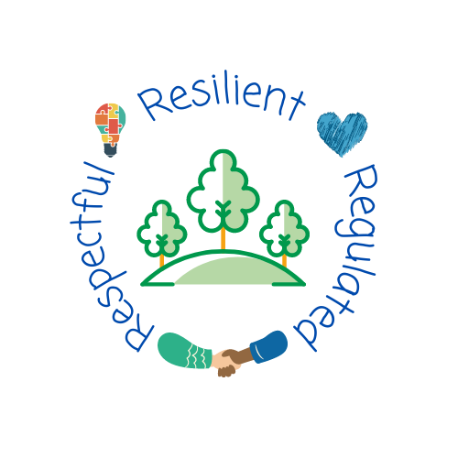

Reading progression of knowledge and skills across Early Years and Key Stage One

Sep 2023
Progression of knowledge and skills within Reading
Intent
At Brampton Cortonwood Infant School we are committed to the delivery of excellence in the teaching of Phonics. We aim to develop each child so that they are able to read with fluency as well as develop a love of reading that will stay with them for the rest of their life. We use the systematic and structured Phonics Programme Floppy’s Phonics. Floppy’s Phonics is in line with the Systematic Synthetic Phonics (SSP) teaching principles described in the ‘English programmes of study, for early years and key stages 1 which was statutory from September 2014. Not all words in the English language comply to the rules of phonics so we also teach so-called ‘sight words’ and ‘common exception words’ by repetition, retrieval and emphasising which parts of the word doesn’t comply to the rule of phonics so that children are able to build an attached memory to those words. This will aid with fluency and speed when children are reading.
We give high priority to reading, our children are exposed to a range of high-quality texts, and there are areas around school where children are encouraged to enjoy reading for pleasure. All children visit the school library weekly and choose a book that they are interested in. This may be a book that they are able to read independently or a book that can be enjoyed with parent support. When children are able to blend they have access to individually levelled phonically decodable online reading books at home and in school, the children also have a school reading book that is a phonically decodable book that matches their Floppy’s Phonics reading level. Once a child has completed a Floppy’s Phonics reading level, they are able to select a book from the appropriate book band level that matches their own reading level. All children read during Floppy’s Phonics sessions and are individually heard read at least once a week by a member of staff In Years 1 and 2 children have guided reading sessions five times a week with a focus on comprehension.
In F1 our children’s reading journey begins with Guided Talk sessions. This involves the children using wordless picture books to practise key skills like how to hold a book and turn a page and how to track from left to right when looking at the sequence of pictures. In these sessions the children talk about what they can see, with an adult, and share their thoughts and opinions about what they think might be happening in the story.
In F2, at the appropriate point within the Autumn or Spring term based on the cohort’s current reading ability, the children begin group guided reading sessions. These sessions focus on comprehension with an element of phonic decoding as appropriate. This also is an opportunity for children to be exposed to their ‘sight words’ which they are encouraged to spot within the text they are reading. Quality story sessions are timetabled in daily and there is an emphasis on developing a love of books, vocabulary and understanding, which is evident within classroom reading areas that display specific class texts and a book of the week.

We want all our children to be fluent readers –regardless of their starting point and barriers to learning. For those children identified as working below the expected standard in reading, the school provides further support in various ways. Such as offering ‘keep up’ sessions to encourage reluctant readers to engage with reading and ‘catch up’ sessions alongside key staff who are trained to delivering a Floppy’s Phonics ‘catch up’ programme tailored to meeting the specific needs of those children requiring such a programme.

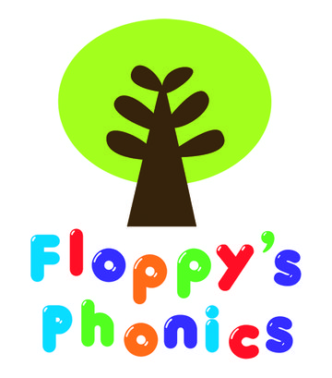

Reading
Strand | Word Reading | Comprehension
Smarties and F1  Children will know how to… | Composite:  - Learning that print has meaning and can have different purposes  - Learning that we read English text from left to right and from top to bottom  - Learning the names of the different parts of a book  - Spot and suggest rhymes  - Count or clap syllables in a word  - Recognise words with the same initial sound, such as money and mother  - Read individual letters by saying the sounds for them  - Blend sounds into words, so that they can read short words made up of known letter– sound correspondences.  - Read some letter groups that each represent one sound and say sounds for them. | - Engage in extended conversations about stories, learning new vocabulary
Components:
- Guided talk
- Phonics sessions (environmental sounds)
- Tiny talkers
- Story time
F2  Children will know/ know how to… | Composite:  - Read individual letters by saying the sounds for them.  - Blend sounds into words, so that they can read short words made up of known letter– sound correspondences  - Read some letter groups that each represent one sound and say sounds for them.  - Read a few common exception words matched to the school’s phonic programme.  - Read simple phrases and sentences made up of words with known letter–sound correspondences and, where necessary, a few exception words  - Re-read these books to build up their confidence in word reading, their fluency and their understanding and enjoyment.  - Say a sound for each letter in the alphabet and at least 10 digraphs;  - Read words consistent with their phonic knowledge by sound-blending;  - Read aloud simple sentences and books that are consistent with their phonic knowledge, including some common exception words | Composite:  - Demonstrate understanding of what has been read to them by retelling stories and narratives using their own words and recently introduced vocabulary;  - Anticipate – where appropriate – key events in stories;  - Use and understand recently introduced vocabulary during discussions about stories, non-fiction, rhymes and poems and during role-play.  - Participate in discussions about what it read to them, taking turns and listening to what others day  - Explain clearly their understanding of what is read to them
 | Components:  - Daily phonics sessions  - Poetry basket  - Story time  - Individual readers  - Home book/library book | Children will learn the following common exception words:  a the to of are my go no me he she we be you is was I  Expected book band coverage:  pink, red, yellow
Strand | Word Reading |  | Comprehension
Year 1  Children will know/ know how to… | Composite  - apply phonic knowledge and skills as the route to decode words  - respond speedily with the correct sound to graphemes (letters or groups of letters) for all 40+ phonemes, including, where applicable, alternative sounds for graphemes  - read accurately by blending sounds in unfamiliar words containing GPCs that have been taught  - read common exception words, noting unusual correspondences between spelling and sound and where these occur in the word  - read words containing taught GPCs and –s, –es, –ing, –ed, –er and –est endings  - read other words of more than one syllable that contain taught GPCs  - read words with contractions [for example, I’m, I’ll, we’ll], and understand that the apostrophe represents the omitted letter(s)  - read aloud accurately books that are consistent with their developing phonic knowledge and that do not require them to use other strategies to work out words  - re-read these books to build up their fluency and confidence in word reading. |  | Composite:  - develop pleasure in reading, motivation to read, vocabulary and understanding by:  - listening to and discussing a wide range of poems, stories and non-fiction at a level beyond that at which they can read independently  - being encouraged to link what they read or hear read to their own experiences  - becoming very familiar with key stories, fairy stories and traditional tales, retelling them and considering their particular characteristics  - recognising and joining in with predictable phrases  - learning to appreciate rhymes and poems, and to recite some by heart  - discussing word meanings, linking new meanings to those already known  - understand both the books they can already read accurately and fluently and those they listen to by:  - drawing on what they already know or on background information and vocabulary provided by the teacher  - checking that the text makes sense to them as they read and correcting inaccurate reading  - discussing the significance of the title and events  - making inferences on the basis of what is being said and done  - predicting what might happen on the basis of what has been read so far
 | Components:  - daily phonics sessions  - individual readers  - guided reading sessions  - story time  - home book/library book  - reading for pleasure sessions  - common exception word lesson weekly | Children will learn the following common exception words:  Do today said says are were his has your they so by here there where love some come one once ask friend school put push pull full house out  Expected book band coverage:  blue, green, orange
Strand | Word Reading |  | Comprehension
Year 2  Children will know/ know how to…. | Composite:  - continue to apply phonic knowledge and skills as the route to decode words until automatic decoding has become embedded and reading is fluent  - read accurately by blending the sounds in words that contain the graphemes taught so far, especially recognising alternative sounds for graphemes  - read accurately words of two or more syllables that contain the same graphemes as above  - read words containing common suffixes  - read further common exception words, noting unusual correspondences between spelling and sound and where these occur in the word  - read most words quickly and accurately, without overt sounding and blending, when they have been frequently encountered  - read aloud books closely matched to their improving phonic knowledge, sounding out unfamiliar words accurately, automatically and without undue hesitation  - re-read these books to build up their fluency and confidence in word reading. |  | Composite:  - develop pleasure in reading, motivation to read, vocabulary and understanding by:  - listening to, discussing and expressing views about a wide range of contemporary and classic poetry, stories and non-fiction at a level beyond that at which they can read independently  - discussing the sequence of events in books and how items of information are related  - becoming increasingly familiar with and retelling a wider range of stories, fairy stories and traditional tales  - being introduced to non-fiction books that are structured in different ways  - recognising simple recurring literary language in stories and poetry  - discussing and clarifying the meanings of words, linking new meanings to known vocabulary  - discussing their favourite words and phrases  - continuing to build up a repertoire of poems learnt by heart, appreciating these and reciting some, with appropriate intonation to make the meaning clear  - understand both the books that they can already read accurately and fluently and those that they listen to by:  - drawing on what they already know or on background information and vocabulary provided by the teacher  - checking that the text makes sense to them as they read and correcting inaccurate reading  - making inferences on the basis of what is being said and done  - answering and asking questions  - predicting what might happen on the basis of what has been read so far  - participate in discussion about books, poems and other works that are read to them and those that they can read for themselves, taking turns and listening to what others say  - explain and discuss their understanding of books, poems and other material, both those that they listen to and those that they read for themselves
 | Components:  - daily phonics sessions  - individual readers  - guided reading sessions  - story time  - home book/library book  - reading for pleasure sessions  - common exception word lesson weekly | Children will learn the following common exception words:  Floor door poor because find kind mind behind child children wild climb most only both old cold gold hold told every everybody even great break steak pretty beautiful after fast past last father class grass pass plant path bath hour move prove improve sure sugar eye could should would who whole any many clothes busy people water again half money Mr Mrs parents Christmas  Expected book band coverage:  turquoise, purple, gold (white, lime, brown, grey)

Floppy’s Phonics sounds progression
 | Sounds taught | Decodable books
Level 1  Lilac |  | At the Farm: Out in Town, Fun at school, at Home; At the Park; At the Match, At the Concert; At the Carnival, At the Seaside, At the Market, At the Party, At the Wildlife Park
Level 1+  Pink | s a t p i n m d g o c k ck e u r h b f ff l ll ss | Cats  Pop  A big Mess  Big Bad Bug  Hats  Mud
Level 2  Green | j v w book 7  x y z book 8  zz qu ch book 9  sh th ng book 10 | Quiz  A Robin’s Egg  Jack  Bang the Gong  Posh Shops  The Zip
Level 3  Blue | ai, ee, igh book 13  oa, oo, oo, book 14  ar, or, ur, book 15  ow, oi, ear book 16  air, er, er book 17 | Leek Hotpot  Queen’s Maid  A Bark in the Night  Toads in the Road  Silver Foil Rocket  Chairs in the Air
Level 4  Red | Revising and blending  CVCC CCVC phonics  a e i o u s t p n m d g c k ck r h b f ff l ll le ss j v w x y z zz qu ch sh th ng nk ai ee igh oa oo o oar or ur ere r ow oi ear air  book 19,20  ay, a-e, book 21, 25  y, ie, ea, e-e book 21, 25  ie, i-e book 21, 26  ow, oe, o-e book 22, 26  u-e, ue, ew book 18, 29  ue, ew, u-e book 18, 29  oy book 21, 30  ou book 22  aw, au, ore book 30, 36  ir book 23, 31  nk, tch, ve book 11, 12  are, ear book 35  /e/ ea book 27, 24  wh, ph book 11, 32  -ed book 24 | Painting the Loft  The Lost Chimp  The Crab Dragon  Crunch!  Green Planet Kids  No Tricks Gran!  The Gale  Rowing Boats  Mr Scroop’s School  Please do not Sneeze  The Missing Crystal  The Haunted House
Level 5  Gold  (SPAG) | j, dge -ge, g book 11, 28,  s, ci, ce, cy book 27  n, kn, gn book 35  r, wr book 35  l, ll, le, el, al, il book 28  igh, ie, i-e, y, book 26  u, o book 31  ee, ea, y, e-e, ie, ey book 25  o, a book 31  er, ir, ur, or book 23, 31  or, aw, au, ore, ar book 23, 30  sh, tion book 34  ai, ay, a-e, a, ea, ey, ea book 25  red= taught in previous levels | Orange and above

Fridays- consolidation day, high frequency words/ common exception words teaching
By the end of ____ the children should be able to read and write:
F2  a the to of are my go no me he  she we be you is was I | Year 1  Do today said says are were his has your they so by here there where love some come one once ask friend school put push pull full house out
Year 2
Floor door poor because find kind mind behind child children wild climb most only both old cold gold hold told every everybody even great break steak pretty beautiful after fast past last father class grass pass plant path bath hour move prove improve sure sugar eye could should would who whole any many clothes busy people water again half money Mr Mrs parents Christmas

Floppy’s Phonics Guide
Teaching resources login
Username hstewart@bc.jmat.org.uk
Password Cortonwood1!
Revisit – previous level sounds | Past sounds (not pictures on the card), spot the sound and read the words (At pace)
Review – most recent weekly sound | Sounds of the week- say the sounds and the pictures.  Left hand- back to children oral segment the picture cue. Turn over to oral segment the words.
Teach | The new sound and the picture  - Say picture name and practise saying todays sound and where it is in the word of the image. YSIS (my turn, your turn)  - look at the freeze and sound mats (mention other alternatives of that sound)  - Orally blend the words on the card, say the word slowly, pinch the sounds on your left hand that make up that word.  Learning book (electronic)  - Look at the book page discuss who, what, why, when  - Oral blend the words on the board  - Alien words (practice reading some nonsense words)  - (MOVE TO TABLE) spell words with your *new* sound. Children at the end of level 4 should spell a range of words with different alternate graphemes and have to select the correct grapheme (ay, ai, a-e)  - Spell the words on the chip icon (children record in their book)  - Count the sounds and teacher to make dashes on the whiteboard for the sounds in a word, children give the sounds to the teacher to fill in.  - Check the sounds  - Re-write the word without dashes and say each name.  - Tick and Fix (children write the word correct at the side without dashes).
Practise | Worksheet (word bank)  - Spot today’s grapheme by underlining the grapheme in every word. (children say the phoneme as they underline each grapheme).  - Sound out and blend the words for reading (encourage where appropriate children to read without blending)  - Once blended correctly, children can tick the words and cross the words they can’t read. Children to circle any words they don't understand the meaning of.  - Whole class blending of words that children have crossed and discuss the meaning of the words children have circled.
Apply | Cumulative text  - Grapheme search linked to today’s sounds  - Underline todays grapheme in the words.  - Read the sentence strip  - Draw a picture linked to the sentences on strip (assessment purpose for reading and understanding)  - Hold a sentence/ teacher dictation of pre-thought of sentence  - Whole class to spell the sentence back to the teacher once they have written it then children to tick and fix sentence in their book.  Consolidation  - Use the cumulative text in the book

Floppy’s Phonics Guide – Level 1 / F2

Day 1 of new sound (focus on reading)
Revisit – previous level sounds | Past sounds (not pictures on the card), spot the sound and read the words (At pace)
Review – most recent weekly sound | Sounds of the week- say the sounds and the pictures.  Left hand- back to children oral segment the picture cue. Turn over to oral segment the words.
Teach | The new sound and the picture  - Say picture name and practise saying todays sound and where it is in the word of the image.  - Magic writing, look at the freeze and look at the alphabetic code (mention other alternatives of that sound)  - Spelling the words on the card, say the word slowly, pinch the sounds on your left hand that make up that word.  - Count the sounds and ask where you can hear the new sound that you are learning.  Learning book (electronic)  - Look at the book page discuss who, what, why, when  - Oral blend the words on the board  - If applicable segment some additional CVC words.
Practise | Say the sounds poster  - Say the sounds on the poster sheet (in plastic wallet), model pointing to each sound and saying it – can you point spot the new sound we are learning?  In books (carpet):  Worksheet  - Read sounds by pointing to each one in turn.  - Sound out and blend the words for reading (encourage where appropriate children to read without blending (Hold it in your head)  - Adults to move round the room listening to children saying the sounds and segmenting and blending words and tick with their green marking pen.  - Whole class blending of words that children have struggled with.
Apply | Cumulative text  - Grapheme search linked to today’s sounds  - Read the text strips (1)  - Adults to move round the room listening to children reading the sentence and tick with their green marking pen.  - Whole class reading of sentence with children pointing to words and reading along with the adult.  Consolidation  - Use the cumulative text in the book

Floppy’s Phonics Guide – Level 1 / F2

Day 2 of new sound (focus on spelling/writing)
Revisit – previous level sounds | Past sounds (not pictures on the card), spot the sound and read the words (At pace)
Review – most recent weekly sound | Sounds of the week- say the sounds and the pictures.  Left hand- back to children oral segment the picture cue. Turn over to oral segment the words.
Teach  (this will be quicker as you introduced it yesterday) | The new sound and the picture  - Say picture name and practise saying todays sound and where it is in the word of the image.  - Magic writing, look at the freeze and look at the alphabetic code (mention other alternatives of that sound)  - Spelling the words on the card, say the word slowly, pinch the sounds on your left hand that make up that word.  - Count the sounds and teacher to make dashes on the whiteboard for the sounds in a word, children give the sounds to the teacher to fill in.  Learning book (electronic)  - Look at the book page discuss who, what, why, when  - Oral blend the words on the board
Practise | In books (at tables) spell the words on the board (children record in their book):  - Spot today’s grapheme by underlining it (yesterday’s sheet)  - Model using dashes to write first word (do all together)  - Sound out word for spelling, count the sounds and get children to draw the correct amount of dashes.  - Children to spell the word using dashes  - Check the sounds  - Re-write the word without dashes and say each sound. Tick or fix.
Apply | Cumulative text  - Say dictated sentence (2)  - Count the words  - Whole class to spell the sentence back to the teacher, once they have written it then children to tick and fix sentence in their book.  Consolidation  - Use the cumulative text in the book

Book banding
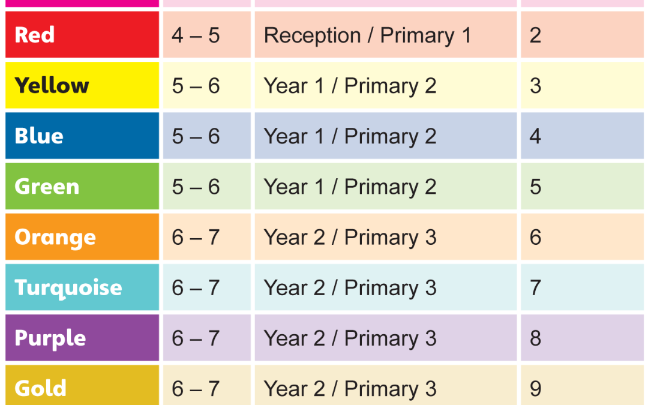

Reading Domains

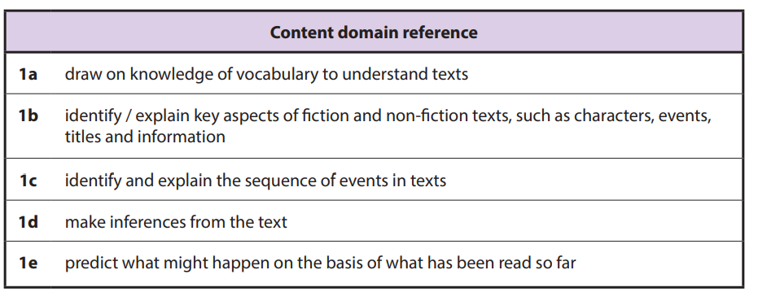

Appendix 1
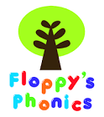
Name:________________ Date:
Say the sounds assessment.
s a t p i n m d g o c k ck
e u r h b f ff l ll ss
sat pat nip dog cat man duck doll

j v w x y z zz qu ch sh th ng
quiz chick ship chop ring

ai ee igh oa oo oo ar
or ur ow oi ear air er
er
rain deep night goat moon
cook card fork fur down coil hear hair hammer herbs

ay a-e y ie ea e-e ie i-e ow oe o-e ue u-e ue u-e ew ew oy ou aw au ore ir nk tch ve are ear ea wh ph ed

sink hatch give play came eat Pete cried like toes glue rescue screw news flute tube boy shirt paw launch mouth
bread field sore bear share happy phone wheel dropped

dge g ge ci ce cy kn gn wr le el al il y o ey /o/ or ar -s tion ea ure

badge circle centipede cycle knight gnaw wrap bottle parcel hospital pencil cry son Monday turkey watch word warm treasure potion great sure picture

Appendix 2
School Reading Record
Name…………………………………………….
Class ……………………………………………….

Date | Level and Band | Book | page | star | wish | Staff member

Appendix 3

Guided Reading: Group W.c: Text: Craig Saves the Day Blue
Introduction  3 min | Introduce key learning objectives.  Discuss key aspects of the book e.g genre, author, illustrator, title, blurb and front and back cover.  Walk through the book introducing children to tricky words and focus phonemes e.g. ai, ay, a-e, a, ee  Familiarise children with new vocabulary and unfamiliar ideas e.g. leaders, days out, camping  Tricky words: said so out she was the me
Key Learning  Points  5 min | Check recognition of tricky/unfamiliar words or word endings  Model blending and segmenting and then quick flash to encourage children to read known words from memory.
Independent  Reading  10min | Set a purpose for reading and focus on key questions that will be discussed after reading.  The children will then read quietly at own pace while the teacher listens to individuals in turn. Prompt and praise good strategies especially those that are objective specific. (PTO)  Independent task for those who have finished – WB and pen- find words containing todays grapheme
Content Domains | 1a draw on knowledge of vocabulary to understand texts | 1b identify / explain key aspects of fiction and non-fiction texts, such as characters, events, titles and information | 1c identify and explain the sequence of events in texts | 1d make inferences from the text | 1e predict what might happen on the basis of what has been read so far
Questions | What is a leader? | Which team was Wilf in? | What happens at the end of the story? | Why did they have to wait for Craig? | Look at the cover and title. What do you think will happen in this story?

Appendix 4
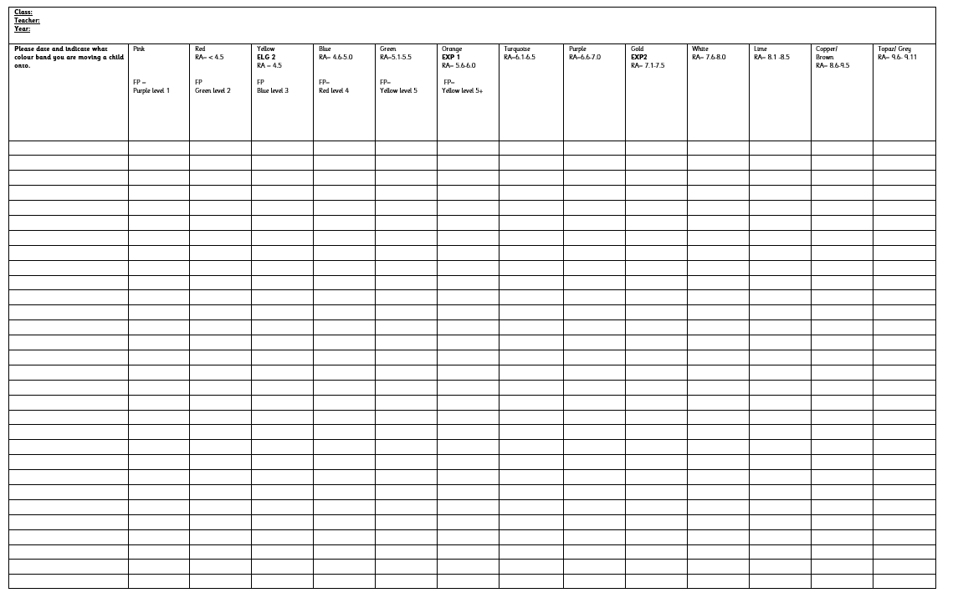
Appendix 5
2 week rolling program teacher and TA role switch
Groups | Monday | Tuesday | Wednesday | Friday
Chip (LA) | Teacher group  (Chip) | TA– Listen to child read individual book  (chip) | Pleasure | Independent  Read of guided reading book
Biff (LA/MA) | Independent read of guided reading book | Teacher group  (Biff) | TA– Listen to child read individual book  (Biff) | Pleasure
Wilma (MA) | Pleasure | Independent  Read of guided reading book | Teacher group  (Wilma) | TA – Listen to child read individual book  (Wilma)
Wilf (HA) | TA – Listen to child read individual book  (Wilf) | Pleasure | Independent  Read of guided reading book | Teacher group  (Wilf)

