Cortonwood Infant and Nursery School
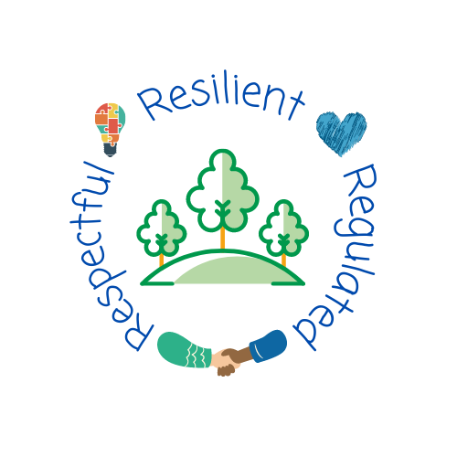

English long term plan across Early Years and Key Stage One

Sep 2022

Brampton Cortonwood Infant School
English Long Term Plan 2022-2023
Nursery (F1)

Term | Autumn 1 |  |  |  |  |  |  |  |  | Autumn 2
Topic | Incredible Me |  |  |  |  |  |  |  | Celebrations
Weeks | 1 | 2 | 3 | 4 | 5 | 6 | 7 |  |  | 1 | 2 | 3 | 4 | 5 | 6 | 7
Text/Stimulus | Whiffy Wilson- A wolf that wouldn’t go to school | Harry and the dinosaurs- starting school | Colour monster goes to school  Colour monster | Making friends | Families | My amazing body | Whiffy Wilson |  |  | Room on a broom | We’re going on a leaf hunt | Leaf Man | How to catch a star | It was a cold dark night | Nativity | Stickman  A Crayon’s Christmas

Term | Spring 1 |  |  |  |  |  |  |  |  | Spring 2
Topic | Winter Wonderland |  |  |  |  |  |  |  | Traditional Tales
Weeks | 1 | 2 | 3 | 4 | 5 | 6 | 7 |  |  | 1 | 2 | 3 | 4 | 5 | 6 | 7
Text/Stimulus | Say hello to the snowy animals | Jack Frost | Gruffalo’s child | Ridiculous | Harry and the snow king | Chinese New Year non-fiction | Linked to children’s interest |  |  | Mr Wolf’s pancakes | Once upon a time | The three little pigs | The gingerbread man | Goldilocks and the three bears | Magic Key adventures

Term | Summer 1 |  |  |  |  |  |  |  |  | Summer 2
Topic | Roots, Shoots and Juicy Fruits |  |  |  |  |  |  |  | Under the Sea
Weeks | 1 | 2 | 3 | 4 | 5 | 6 | 7 |  |  | 1 | 2 | 3 | 4 | 5 | 6 | 7
Text/Stimulus | Oliver’s vegetables | Titch | Tiny seed | Bee | Hungry caterpillar | Handa’s surprise | Which food will you choose? |  |  | Commotion in the ocean | Little people, big dreams David Attenborough | Sharing a shell | Snail and the whale | What the ladybird heard at the seaside | The lighthouse keeper’s lunch
>>Pass things from one hand to the other. Let go of things and hand them to another person, or drop them. (EYFS Birth-Three)
>Build independently with a range of appropriate resources. (EYFS Birth-Three)
>Use large and small motor skills to do things independently, for example manage buttons and zips, and pour drinks. (EYFS Birth-Three)
>Show an increasing desire to be independent, such as wanting to feed themselves and dress or undress. (EYFS Birth-Three)
>Use one-handed tools and equipment, for example, making snips in paper with scissors. (EYFS Three to Four)
>Use a comfortable grip with good control when holding pens and pencils .(EYFS Three to Four)
>Show a preference for a dominant hand. (EYFS Three to Four)
>Be increasingly independent as they get dressed and undressed, for example, putting coats on and doing up zips. (EYFS Three to Four)
>Write some or all of their name. (EYFS Three to Four) >Write some letters accurately. (EYFS Three to Four)
Reception (F2)

Term | Autumn 1 |  |  |  |  |  |  |  |  |  |  |  |  |  | Autumn 2
Topic | Marvellous me! |  |  |  |  |  |  |  |  |  |  |  | Celebrations
Weeks | 1 | 2 |  | 3 | 4 |  |  | 5 |  |  |  |  |  |  | 1 |  |  | 2 |  | 3 |  | 4 |  | 5 | 6
Text/Stimulus | What makes me a ‘me’? | Home |  | The Little Red Hen | Pumpkin soup |  |  | Owl Babies |  |  |  |  |  |  | The Squirrels who Squabbled |  |  | Bonfire Night- Non-fiction |  | Rama and Sita |  | The Christmas story |  | Jolly Postman
Genre | Name writing  I like… | Draw their home and label  Sequence events from local walk  Create simple map |  | Orally retelling the story  Initial sounds  CVC label writing | Simple instructions to match a picture |  |  | Speech bubbles with feelings |  |  |  |  |  |  | Sentence writing to match a picture  Poetry basket- Furry Squirrel |  |  | Sequencing events  Label writing  CVC words  Writing onomatopoeia words to describe fireworks |  | Describe how the characters felt at different points in the story |  | Sequencing  Card writing |  | Letter to Santa
Grammar/ composition | >Children at the expected level of development will:  >Write recognisable letters, most of which are correctly formed  >spell words by identifying sounds in them and representing the sounds with a letter or letters  >write simple phrases and sentences that can be read by others. |  |  |  |  |  |  |  |  |  |  |  |  |  | >Children at the expected level of development will:  >Write recognisable letters, most of which are correctly formed  >spell words by identifying sounds in them and representing the sounds with a letter or letters  >write simple phrases and sentences that can be read by others.
Term | Spring 1 |  |  |  |  |  |  |  |  |  |  |  |  |  |  | Spring 2
Topic | Amazing animals in winter |  |  |  |  |  |  |  |  |  |  |  |  | Down on the Farm
Weeks | 1 |  | 2 | 3 | 4 | 5 |  |  | 6 |  |  |  |  |  |  | 1 | 2 |  | 3 |  | 4 | 5 | 6
Text/Stimulus | Lost and found |  |  | Animals in winter | The Great explorer |  | Harry and the bucket of dinosaurs |  |  | Mary Anning |  |  |  |  |  | What the ladybird heard |  |  | What the ladybird heard next |  | Billy goats Gruff |  | 10001 things to do on a farm
Genre | Draw and label a picture from the story  Complete sentences  (The penguin is…)  ‘Found’ poster |  |  | Label the animals  (fox, bat, rabbit) | List of things to pack for an artic adventure |  | One-word poetry |  |  | Fact file sentences |  |  |  |  |  | Book review  Description of character feelings |  |  | ‘wanted’ poster |  | Story sequencing  Story labelling |  | Trip recount
 | >Children at the expected level of development will:  >Write recognisable letters, most of which are correctly formed  >spell words by identifying sounds in them and representing the sounds with a letter or letters  >write simple phrases and sentences that can be read by others. |  |  |  |  |  |  |  |  |  |  |  |  |  |  | >Children at the expected level of development will:  >Write recognisable letters, most of which are correctly formed  >spell words by identifying sounds in them and representing the sounds with a letter or letters  >write simple phrases and sentences that can be read by others.

Term | Summer 1 |  |  |  |  |  |  |  |  | Summer 2
Topic | Plants |  |  |  |  |  |  |  | Across the sea
Weeks | 1 | 2 | 3 | 4 | 5 | 6 | 7 |  |  |  | 1 | 2 | 3 | 4 |  | 5 | 6
Text/Stimulus | Jack and the Beanstalk |  | Oliver’s fruit salad |  | Mabel’s magic garden | From seed to sunflower | From chick to chicken |  |  |  | The Three Little Pigs |  | Zog |  | Coming to England | Transition  Revisiting key texts from the year
Genre | Story sequencing  Writing about key events in the story |  | Descriptive writing about the vegetables/fruits |  | Label the basic parts of a plant | Instructions | Life cycle with labels (egg, hatch, chick, hen) |  |  |  | Rewrite the story in their own words  Character description of the big, bad wolf |  | Design and describe a dragon |  | Write a postcard  Fact file | Book reviews  Letter to their new teacher
 | >Children at the expected level of development will:  >Write recognisable letters, most of which are correctly formed  >spell words by identifying sounds in them and representing the sounds with a letter or letters  >write simple phrases and sentences that can be read by others. |  |  |  |  |  |  |  |  |  | >Children at the expected level of development will:  >Write recognisable letters, most of which are correctly formed  >spell words by identifying sounds in them and representing the sounds with a letter or letters  >write simple phrases and sentences that can be read by others.

Year 1
Term | Autumn 1 |  |  |  |  |  |  |  |  |  |  |  |  |  |  |  |  |  | Autumn 2
Topic | Myself and my community- Our Village Brampton |  |  |  |  |  |  |  |  |  |  |  |  |  |  |  | Celebrations- Let’s Celebrate
Weeks | 1 | 2 |  | 3 |  |  | 4 | 5 |  |  | 6 |  |  | 7 |  |  |  |  | 1 |  | 2 |  | 3 |  | 4 |  | 5 |  |  |  | 6 | 7
Text/Stimulus | All About Me | Town is by the sea |  |  |  |  |  | The Smile Shop |  |  | The Street Beneath my Feet  Local Walk |  |  |  |  |  |  |  | Bonfire night |  |  |  | Daisy Saves the Day |  |  |  | Pantomime  Jack and the beanstalk
Genre | Writing simple sentences about myself using ‘I’  -appearance  -family  -live  -like | Setting description  I can see... (enormous house)  Character description  Written in 1st person  (I have a thin body and I have tiny, black freckles)  Story retell in first person  (I woke up early in the morning and the sun was shining brightly) |  |  |  |  |  | Character description in first person  Setting description  (There is a brown, creepy wolf. There is a steaming fire. There is a gloomy forest). |  |  | Character description  (I can see a…)  Story Retell in 3rd person  (First the boy, then she, next he) |  |  |  |  |  |  |  | Character description about Guy Fawkes written in 3rd person (Guy Fawkes had a tall hat and he had a scraggy shirt).  Recount of an experience in 1st person linking to the five senses (I can see sparkly fireworks, I can hear…) |  |  |  | Setting description in 1st person  (In my bedroom I have… and I have…)  Story retell in 1st person (First I go to London and I start my new job). |  |  |  | Letter with personal description and instructions to Santa from yourself |  |  |  | Character description written in 3rd person  (The giant had black, matted hair and a large nose)  Narrative- story of Jack and the Beanstalk
Grammar/ composition | >compose a sentence orally before writing it  > write sentences by saying out loud what they are going to write about  >sequencing sentences to form short narratives  >leaving spaces between words  >joining words and clauses using ‘and’  >begin to punctuate using full stops, capital letters  >using a capital letter for names of people, places, days of the week and the pronoun I  >use noun phrases |  |  |  |  |  |  |  |  |  |  |  |  |  |  |  |  |  | >re-reading what has been written to check it makes sense  >discuss what they have written  >read their writing out loud  >leaving spaces between words  >joining words and clauses using ‘and’  >begin to punctuate using full stops, capital letters, exclamation marks and question marks  >using a capital letter for names of people, places, days of the week and the pronoun I  >use noun phrases  >use time adverbials
Term | Spring 1 |  |  |  |  |  |  |  |  |  |  |  |  |  |  |  |  |  |  | Spring 2
Topic | Explore- Ready for Take Off! |  |  |  |  |  |  |  |  |  |  |  |  |  |  |  |  | Animals- All Creatures Great and Small
Weeks | 1 |  | 2 |  |  | 3 |  |  | 4 | 5 |  |  | 6 |  |  |  |  |  |  | 1 |  | 2 |  | 3 |  | 4 |  | 5 | 6
Text/Stimulus | Look up |  |  |  | Non fiction texts linked to Space/Neil Armstrong |  |  |  | The Way Back Home |  |  | The Snail and the Whale |  |  |  |  |  |  |  | Lost and Found  Yorkshire Wildlife Park |  |  |  | Non-fiction texts  Animal experience |  | Meercat Mail |  |  | Gorilla
Genre | Fact file about the Wright brothers  -who are they?  -what did they do?  -when did it happen?  -how far did they fly?  Design a character and write a character description in 3rd person  (Betsy is an astronaut and she has blonde hair)  Story in the style of your created character (Betsy loves to look up and see the stars) |  |  |  | Setting description in 2nd person (you will see… you can see)  Advert advertising space  (In space you will see)  Letter to friend from ‘Neil Armstrong’ |  |  |  | Section of a story in 1st person (I found a red aeroplane in the cupboard)  List- 10 things I would take to space in my rocket  Letter written in the past tense to a family member from yourself (I found a red aeroplane but suddenly the plane started to splutter)  Instructions for how to make a shape rocket  Instructions for how to fix the spaceship |  |  | Diary entry from the perspective of a character with verb phrases (screeching seagulls, flashing lightening, growling bear) |  |  |  |  |  |  |  | Descriptive poster in 1st person  (I have found a penguin. He has a black body and he is feeling sad).  Descriptive writing  (It has eight legs and it is a carnivore). |  |  |  | Newspaper report about a animal experience they have had (On Monday some animals came to Cortonwood) |  | Character description in 3rd person (On Monday Sunny went to his uncle Bob’s house but…)  Recount from a characters perspective (On Monday I met up with my cousin and I…)  Postcard to mum and dad from Sunny (I arrived at Uncle Bob’s house) |  |  |  | Setting description in 3rd person  (Hannah could see a ….)  Narrative- story  Create their own character and write a character description  (He has…, he lives in)  Instructions  How to wash the character they created (First put him in the bath, Then…)
 | >leaving spaces between words  >joining words and clauses using ‘and’  >begin to punctuate using full stops, capital letters, exclamation marks and question marks  >using a capital letter for names of people, places, days of the week and the pronoun I  >noun phrases, expanded noun phrases  >features of standard English  >time adverbials  >coordinate sentences using ‘and, or, but’  >verb phrases |  |  |  |  |  |  |  |  |  |  |  |  |  |  |  |  |  |  | >leaving spaces between words  >joining words and clauses using ‘and’  >begin to punctuate using full stops, capital letters, exclamation marks and question marks  >using a capital letter for names of people, places, days of the week and the pronoun I  >noun phrases, expanded noun phrases  >features of standard English  >time adverbials  >coordinate sentences using ‘and, or, but’  >verb phrases

Term | Summer 1 |  |  |  |  |  |  |  | Summer 2
Topic | Plants- Seeds, Soil and Sunshine |  |  |  |  |  |  | Our World- Brilliant Beaches
Weeks | 1 | 2 | 3 | 4 | 5 | 6 |  |  |  | 1 | 2 | 3 | 4 | 5 | 6
Text/Stimulus | Butterfly life cycle project  Non-fiction books |  | Jim and the beanstalk |  | Traction man |  |  |  |  | Clean up!  Seaside Trip |  | What a waste |  | Where the sea meets the sky
Genre | Non-fiction report about butterflies  -appearance  -habitat  -diet  (butterflies have a…) |  | Character description (Jim)  -appearance  -personality  -background  (Jim is…)  Letter including instructions to the Giant from Jim  (thank you for the coins…  Instructions to keep your new teeth clean…) |  | Setting description of a garden in the past tense  (On a cold day traction man was walking…)  Story retell of traction man  -opening  -build up  -dilemma  -resolution  -closing  (There once was a brave action figure who…)  Recount of a trip  (time adverbials, noun phrases, verb phrases) |  |  |  |  | Setting description (in the sea there is… On the beach there is…)  Acrostic poem (BEACH)  Beach poem (orange sand burning, golden starfish floating) |  | Non-fiction report (How can you save the planet?) |  | Story  Trip recount
 | > write sentences by saying out loud what they are going to write about  >compose a sentence orally before writing it  >sequencing sentences to form short narratives  >re-reading what has been written to check it makes sense  >discuss what they have written  >read their writing out loud  >leaving spaces between words  >joining words and clauses using ‘and’  >begin to punctuate using full stops, capital letters, exclamation marks and question marks  >using a capital letter for names of people, places, days of the week and the pronoun I  >learn the Y1 terminology;  -letter, capital letter, word, singular, plural, sentence, punctuation, full stop, question mark, exclamation mark  >use coordination (and, or, but)  >use subordination (because)  >use noun phrases and expanded noun phrases  >use time adverbials  >use verb phrases |  |  |  |  |  |  |  |  | > write sentences by saying out loud what they are going to write about  >compose a sentence orally before writing it  >sequencing sentences to form short narratives  >re-reading what has been written to check it makes sense  >discuss what they have written  >read their writing out loud  >leaving spaces between words  >joining words and clauses using ‘and’  >begin to punctuate using full stops, capital letters, exclamation marks and question marks  >using a capital letter for names of people, places, days of the week and the pronoun I  >learn the Y1 terminology;  -letter, capital letter, word, singular, plural, sentence, punctuation, full stop, question mark, exclamation mark  >use coordination (and, or, but)  >use subordination (because)  >use noun phrases and expanded noun phrases  >use time adverbials  >use verb phrases

Year 2
Term | Autumn 1 |  |  |  |  |  |  |  | Autumn 2
Topic | Myself and My Community- Near and Far |  |  |  |  |  |  |  | Celebrations- Let’s Remember!
Weeks | 1 | 2 | 3 | 4 | 5 | 6 | 7 |  | 1 | 2 | 3 | 4 | 5 | 6 | 7
Text/Stimulus | Back to School  The truth about my unbelievable summer | Lila and the Secret of Rain |  |  | The Queen’s Handbag  The Queen’s hat |  |  |  | Non-fiction books linked to remembrance  Local Walk to Cenotaph  The day war came |  | Where the Poppies Now Grow |  | My friend, the enemy  Pantomime | A Christmas Truce
Genre | All About me  Recount in 1st person | Setting description  (There is a…)  Character description in 1st person  (I have large, brown eyes and I have a small head).  Story in 3rd person  (once upon a time there was a beautiful, young girl called Lila and she…)- and  . A - !  expanded noun phrases |  |  | Non-fiction report about the Queen  Diary in 1st person  (the strangest thing happened yesterday. I was heading out of Buckingham palace when…)  Instructions  How to get your flying hat back  . A - !  expanded noun phrases  because |  |  |  | Information sheet about WW1  -when it started  -when it ended  -why did it start?  -who joined in?  -when they fought  -deaths  (WW1 started on…)  Celebrations non-fiction  -what?  -why?  -How?  -when?  (we say thank you to the soldiers by… we go to the cenotaph at…)  and, because, but |  | Setting description of Flander’s field  Character description of Ben and Ray in 3rd person  (Ben had round clear glasses but ray doesn’t)  Letter to parents from Ray  Diary from the perspective of Ben or Ray in 1st person  -event, details, feelings  (we rode the horse all the way down the street. We were terrified!)  and, because, but |  | Fact file about Prince Harry and his links to the war in 3rd person  (He was born in…)  Recount of experience (pantomime)  (First we wandered into the hall and we sat down on the long, hard benches).  when | Letter to Santa to explain to him how to deliver your presents  (first quietly open the door and step inside my house. Next silently eat the cookie I have left out for you)  when
 | > write narratives about personal experiences  >writing about real events  >writing for different purposes  >planning or saying out loud what they will write  >writing down ideas/key words including new vocabulary  >learn how to use new punctuation correctly;  -capital letters, full stops, question marks, exclamation marks, commas to separate items in a list, apostrophes  >use expanded noun phrases  >use coordination (and, but, or)  >use time adverbials |  |  |  |  |  |  |  | > write narratives about personal experiences  >writing about real events  >writing for different purposes  >planning or saying out loud what they will write  >writing down ideas/key words including new vocabulary  >learn how to use new punctuation correctly;  -capital letters, full stops, question marks, exclamation marks, commas to separate items in a list, apostrophes  >use expanded noun phrases  >use coordination (and, but, or)  >use time adverbials

Term | Spring 1 |  |  |  |  |  |  | Spring 2
Topic | Explore- Expeditions |  |  |  |  |  | Animals- Sea, Soil or Sky?
Weeks | 1 | 2 | 3 | 4 | 5 |  |  | 1 | 2 | 3 | 4 | 5 | 6
Text/Stimulus | I am Sacagawea | Scott of the Antarctic David, Attenborough non-fiction books |  | Poles Apart |  |  |  | The Dancing Turtle |  | Up and down  Woodland walk | Tadpoles promise
Genre | Recount of Christmas experience  Biography about Sacagawea written in past tense (Sacagawea was born in and died in…) | First person recount about Scott’s expedition to the Antarctic (I couldn’t get warm and I knew I was running out of time)  Non-Chron Report comparing three explorers, Sacagawea, Captain Scott and Attenborough (She was an explorer from the past and she was inspirational because…)  questions, statements |  | Setting description (In this setting there is… I can see a….)  Instructions for how to arrive at the south pole  (Find a friendly, white polar bear and tell him you are lost)  Retell of the story in 3rd person (Once upon a time there was…)  commands  exclamations  if |  |  |  | Character description of the old man in 3rd person (He has short, brown hair and …)  Write an opening of the story  Substitution story  -character  -musical instrument  Letter to the turtle from the children in 1st person  (I really miss you and hope you can return to us soon!)  Commas in a list  Contracted words |  | Non-fiction text about a woodland habitat  -which animals would you find there?  -how do they get their food?  -what does this habitat provide? (science links) | Letter to the caterpillar from the tadpole in 1st person from the characters perspective  (I’m writing to you to express my anger and annoyance. How could you do that to us?)  Book review
 | >planning or saying out loud what they will write  >writing down ideas/key words including new vocabulary  >make simple additions, revisions and corrections to their writing  >learn how to use new punctuation correctly;  -capital letters, full stops, question marks, exclamation marks, commas to separate items in a list, apostrophes  >use expanded noun phrases  >learn how to use the present and past tense correctly, including the progressive form  >use subordination (when, if, because, that)  >use coordination (and, but, or)  >use time adverbials |  |  |  |  |  |  | >planning or saying out loud what they will write  >writing down ideas/key words including new vocabulary  >make simple additions, revisions and corrections to their writing  >learn how to use new punctuation correctly;  -capital letters, full stops, question marks, exclamation marks, commas to separate items in a list, apostrophes  >use expanded noun phrases  >learn how to use the present and past tense correctly, including the progressive form  >use subordination (when, if, because, that)  >use coordination (and, but, or)  >use time adverbials

Term | Summer 1 |  |  |  |  |  |  | Summer 2
Topic | Plants- Rainforest Adventure |  |  |  |  |  | Our World- Weird Weather
Weeks | 1 | 2 | 3 | 4 | 5 |  |  | 1 | 2 | 3 | 4 | 5 | 6
Text/Stimulus | Butterfly life cycle project  Butterfly non-fiction book | Walk to B&Q | Buddy’s rainforest adventure | The Great Kapok Tree |  |  |  | Non-fiction texts | The Storm Whale |  | Numenia and the Hurricane | Storm  Tornadoes! | The day the crayon’s quit
Genre | Non chronological report of a butterfly  -introduction  -Appearance  -Habitat diet  -other facts  (butterflies have a straw-like proboscis) | Recount of an experience in 1st person, past tense  (Last week we trekked to B&Q to find…)  Instructions for how to plant a sunflower seed | Instructions  -How to save a rainforest orangutan  (First search for him swooping and swinging through the vines…) | Retell a familiar story in past tense  (Once upon a time two men wandered into the rainforest and they….)  Persuasive letter in 1st person  (I’m writing to share my opinion on deforestation…) |  |  |  | Fact file about Claude Monet in 3rd person  (He was a famous artist who…) | 1st person recount of day from Noi’s perspective  (I wandered outside and I couldn’t believe my eyes…)  Instructions for how to look after a whale in distress  (First kneel down and check for a heartbeat. Then pour water over him to make sure he is hydrated) |  | Story retell Newspaper report about the earthquake in Chile | poetry  (swirling silver hurricane, twirling huge tornado) | Letters to new teachers (transition)
 | >make simple additions, revisions and corrections to their writing  >evaluating their writing  >re-reading to check for sense  >proofreading to check for errors  >read aloud what they have written  >learn how to use sentences with different forms; statement, question, exclamation, command  >use expanded noun phrases  >learn how to use the present and past tense correctly, including the progressive form  >use subordination (when, if, because, that)  >use coordination (and, but, or)  >use some features of written standard English |  |  |  |  |  |  | >make simple additions, revisions and corrections to their writing  >evaluating their writing  >re-reading to check for sense  >proofreading to check for errors  >read aloud what they have written  >learn how to use sentences with different forms; statement, question, exclamation, command  >use expanded noun phrases  >learn how to use the present and past tense correctly, including the progressive form  >use subordination (when, if, because, that)  >use coordination (and, but, or)  >use some features of written standard English

Oliver Jeffers
Who school author/illustrator

Foundation Stage 1  The Crayons Christmas  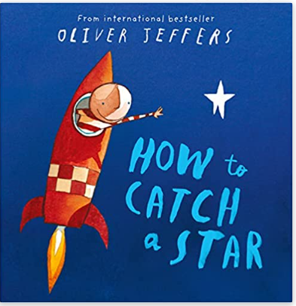 | Foundation Stage 2  Lost and Found  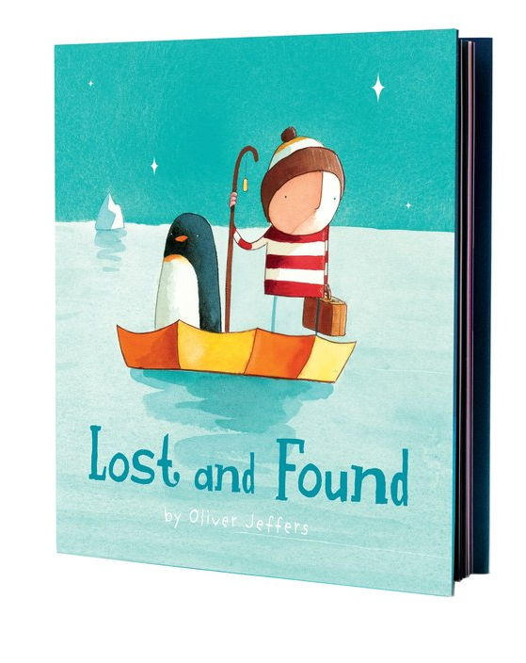
Year 1  The Way Back Home  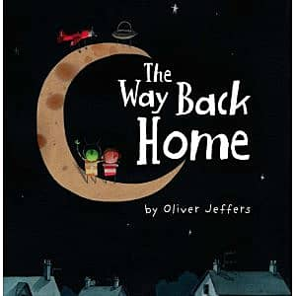 | Year 2  Up and Down  