Cortonwood Infant and Nursery School
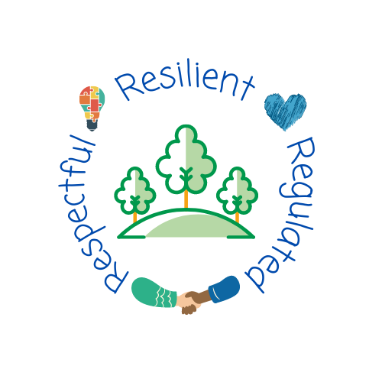

Oracy progression of knowledge and skills across Early Years and Key Stage One

November 2023
Progression of knowledge and skills within Oracy
Intent
Oracy is the ability to communicate and articulate one’s ideas effectively through spoken language. It can be described as the process of children learning how to listen, speak clearly and communicate expressively in a variety of situations.
At Brampton Cortonwood Infant and Nursery School we believe that spoken language and communication is at the heart of the curriculum, a powerful tool for learning and thriving. Our intention is for our children to become confident, articulate communicators with good listening skills and a wealth of vocabulary to use in a range of contexts. Oracy underpins the development of all subjects, especially reading and writing. It empowers children from all backgrounds to find their own voice, developing their confidence, independence and ability to learn, becoming an active member of the classroom. We aim for our children to talk effectively within school, but also equip them for their future.
Oracy opportunities are woven across the curriculum with teachers embedding a culture of talk in the classroom, whereby children can learn the communication skills needed to be successful in both academic life and outside of school. All staff model good vocabulary and language at all times, demonstrating an enthusiasm for learning new vocabulary and using topic specific language. Talk is promoted in the classroom through partner talk, class discussions, circle times and opportunities to present learning to peers.
A positive culture of Oracy is embedded throughout school; we facilitate Oracy throughout the school day, alongside the curriculum. This is achieved through talk opportunities such as; assemblies led by the children, school productions, snack and lunchtime discussions. We celebrate great examples of Oracy and aim to promote good language and communication.

Oracy
Skill | Nursery (F1) | Reception (F2) | Year 1 | Year 2
Physical | - Speak clearly so they can be heard.  - Look at someone who is speaking.  - Begin to use gestures and appropriate hand signals when talking e.g. pointing, bigger/smaller.  - Listen for increasing intervals of time (15 minutes adult directed carpet sessions). | - Speak clearly so they can be heard and understood.  - Look at someone who is speaking and when speaking to others.  - Turn to face your partner.  - Begin to use gestures to support delivery meaning e.g. using actions to retell a story.  - Listen attentively for increasing intervals of time in a range of situations (extended periods for a story, sustained periods for group learning.) | - Speak clearly and confidently in a range of contexts.  - Project the voice so the audience can hear clearly, selecting appropriate tone.  - Turn to face your partner. Maintain eye contact when talking and listening.  - Continue to use gestures and actions explain learning.  - Use body language to show active listening and understanding e.g. nodding, leaning in. | - Speak clearly and confidently in a range of contexts, with appropriate volume.  - Project the voice so the audience can hear clearly, selecting appropriate tone and pace.  - Turn to face your partner.  - Maintain eye contact when talking and listening with familiar and unfamiliar adults.  - Confidently use gestures and actions to support speech and present learning.  - Use body language and facial expressions to show active listening and when speaking e.g. nodding, leaning in.
Vocabulary | 1, 2, 3 eyes on me  Big voice  Use your words  Listening ears | 1, 2, 3 eyes on me  Big voice  Use your words  Listening ears  Put that in a sentence  Partner talk | 1, 2, 3 eyes on me  Big voice  Use your words  Listening ears  Put that in a sentence  Partner talk  Story voice  Indoor voice  Nodding, leaning in | Facial expressions Acknowledgement  Concentration  Volume  Pace  Tone of voice  Gestures
Linguistic | - Use new vocabulary words in play.  - Communicate needs through talk and gestures e.g. putting their coat on, going to the toilet.  - Begin to speak in simple sentences e.g. the baby owl is small, put on my coat please | - Understand and use a range of newly taught subject specific vocabulary words in play.  - Use talk to communicate needs, ideas and opinions e.g. I am going to put my coat on to go outside.  - Begin to speak in sentences, joining phrases together with and or because e.g. The baby owl is small and brown. | - Use vocabulary appropriate to the subject.  - Speak in full sentences, using conjunctions to link ideas e.g. The baby owl is small and lives in a nest.  - Use conjunctions and time adverbials to organise ideas coherently e.g. First the owl wakes up and then sits on the branch.  - Begin to use sentence stems to continue and expand upon the discussion e.g. I agree because...  - Speak like an expert e.g. using learned subject specific vocabulary | - Select and adapt appropriate vocabulary for the specific context or situation.  - Speak in full sentences using conjunctions and time adverbs to organise sentences coherently e.g. First the baby owl wakes up and has breakfast but mother owl isn’t there.  - Use sentence stems to continue and expand upon the discussion e.g. I agree/disagree because..., In my opinion..., Do you mean...? Linking to what you said...  - Speak like an expert e.g. using learned subject specific vocabulary.
Vocabulary |  | Describing word  Action word  and  because | Adjectives  Verbs  Conjunctions (and, because, when, but)  Sentence stems  Time adverbials  Vocabulary  Make sense  Speak like an expert | Adjectives  Verbs  Conjunctions (and, because, when, but, if, so)  Sentence stems  Time adverbials  Appropriate vocabulary  Make sense  Speak like an expert
Cognitive | - Begin to answer why questions e.g. Why are you sad? Why is the baby owl sad?  - Engage in class discussions e.g. listening, responding to direct questions, offering relevant contributions.  - Begin to understand a simple question e.g. Where is the baby owl?  - Follow a single step instruction e.g. Put your coat on please. | - Use because to justify their opinion e.g. I like the baby owl because he is fluffy.  - Make relevant contributions to class discussions  - Ask simple questions e.g. Do you like owls?  - Follow instructions with more than one step e.g. Put your coat on and zip it up please.  - Describe events that have happened to them e.g. I went to hospital. I fell over. | - Continue to use because to justify their opinion or an answer, offering reasons. Contribute to class discussions and respond to others’ comments.  - Ask relevant questions.  - Follow instructions with several steps e.g. Put you coat on, zip it up and line up at the door please.  - Disagree politely with someone’s opinion sometimes using the appropriate sentence stems e.g. I disagree because...  - Explain ideas and events in chronological order e.g. I fell over and went to hospital. | - Use because to justify their opinion or an answer, offering reasons.  - Build upon others’ contributions in class discussions.  - Ask relevant questions to continue a discussion.  - Follow instructions with several steps e.g. Put you coat on, zip it up and line up at the door please.  - Make connections with own and others’ experiences.  - Disagree politely with someone’s opinion using sentence stems e.g. I disagree because..
Vocabulary | My turn, your turn  Super sharing  Why? What? Where? How? When? Who? | My turn, your turn  Super sharing  Why? What? Where? How? When? Who?  Question  Because  Instructions  Describe | My turn, your turn  Super sharing  Why? What? Where? How? When? Who?  Question  Because  Instructions  Describe  Justify  Reasons  Relevant  Chronological order  Opinion  Disagree  Politely | My turn, your turn  Super sharing  Why? What? Where? How? When? Who?  Question  Because  Instructions  Describe  Justify  Reasons  Relevant  Chronological order  Opinion  Disagree  Politely  Build on
Social and Emotional | - Look at someone who is speaking.  - Wait for someone to finish talking before speaking.  - Use talk when playing alongside other children. | - Look at someone who is speaking and when speaking to others.  - Take turns to speak when talking in a group.  - Use talk when playing with other children. | - Maintain eye contact when talking and listening.  - Take turns when talking in a pair or group, listening and responding to what others have said.  - Start discussion without an adult present. | - Maintain eye contact when talking and listening.  - Take turns when talking in a pair or group, listening and responding to what others have said.  - Maintain a discussion without an adult present.  - Respect others’ opinions.  - Use discussion toolkit to invite others to join the conversation.  - Be prepared to change your mind.
Vocabulary | Wait  Look  My turn, your turn  1, 2, 3 eyes on me  Show me your eyes | Wait  Look  My turn, your turn  1, 2, 3 eyes on me  Show me your eyes | Wait  Look  My turn, your turn  1, 2, 3 eyes on me  Show me your eyes  Super sharing  Independent talk | Wait  Look  My turn, your turn  1, 2, 3 eyes on me  Show me your eyes  Super sharing  Independent talk  Respect  Remember to be open -minded Discussion toolkit

Appendix 1
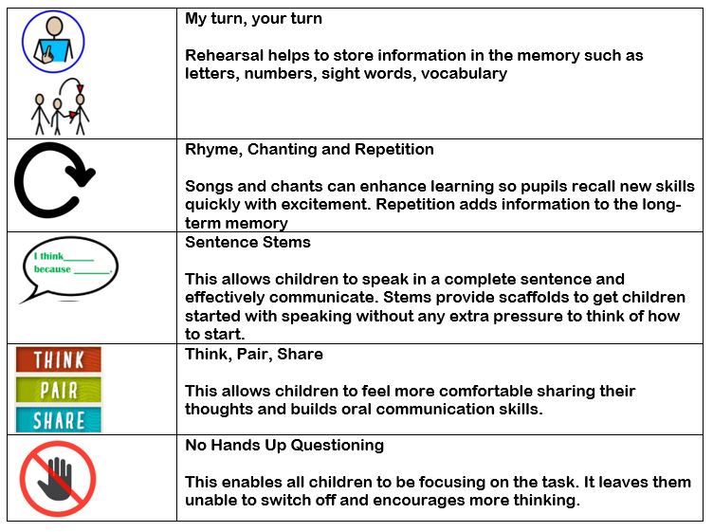
Appendix 2

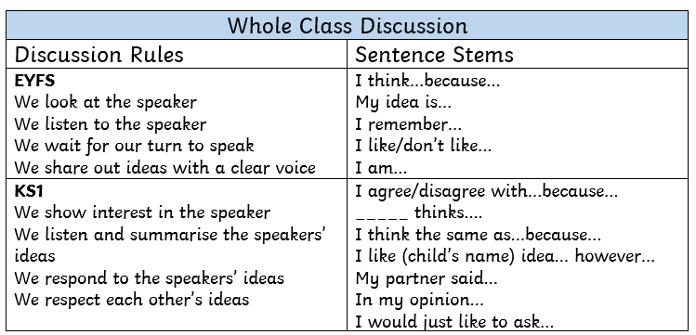

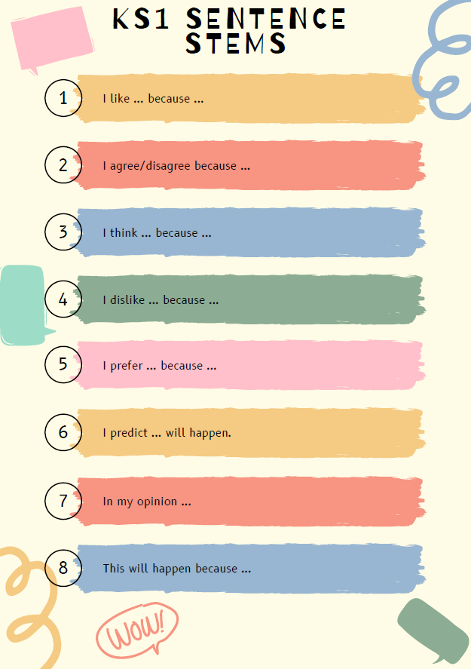
Appendix 3

