Cortonwood Infant and Nursery School

Mathematics method progression for Early Years and Key Stage One

Dec 2022

Addition
Adding single digit numbers that do not cross a ten
5+3=8 | 5+3= 8 | 5+3= 8 | 5+3=8
Adding single digit numbers that cross a ten
7+6= 13 | 7+6= 13 | 7+6= 13 | 7+6= 13  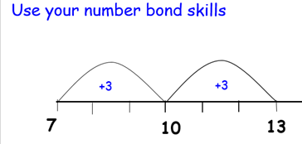
Adding a single digit number to a 2-digit number that do not cross a ten
22+ 4 = 26 | 22+4=26 | 22+4= 26 | 22+4=26
Adding a single digit number to a 2-digit number that does cross a ten
27+5=32 | 27+5= 32 | 27+5= 32 | 27+5=32
Adding two 2-digit numbers that do not cross a ten
34+23 = 57 | 34+23=57  3 tens add 2 tens is 5 tens  4 ones plus 3 ones is 7 ones
Adding two 2-digit numbers that do cross a ten
58+35=93 | 58+35= 93 | 58+35=93 | 58+35= 93

Subtraction
subtracting single digit numbers that do not cross a ten
5-3= 2 | 5-3= 2 | 5-3=2
subtracting a single digit number from a 2-digit number that do not cross a ten
26-3= 23 | 26-3=23 | 26-3= 23 |  | 26-3=23
Subtracting a single digit number from a 2-digit number that does cross a ten
22-5=17 | 22-5= 17 | 22- 5 = 17 |  | 22-5=17
subtracting two 2-digit numbers that do not cross a ten
34-22=57

3 tens subtract 2 tens is 1 ten
6 ones subtract 2 ones is 4 ones

Subtracting two 2-digit numbers that do cross a ten
52-35= 17  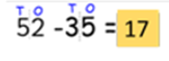 | 52-35= 17 | 52-35=17 |  | 52-35= 17

Multiplication
Arrays  2X4=8  Or | Arrays (commutativity)  2X4= 8  Or |  | Number line (commutativity)  2X4=8  (links with division, 8 shared by 4 equals 2 or 8 shared by 2 equals 4)
Division
Bar model  8÷2= |  | Bar model and number line (dependent on division)  30÷2= 15  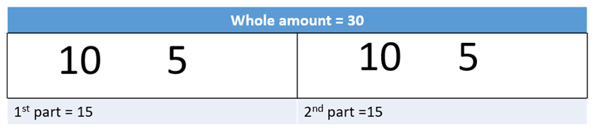  30÷5=6  (links with multiplication, 5 multiplied by 6 equals 30 or 6 lots of 5 or 6 5s go into 30)
Fractions of a number
Bar model for working out a fraction of a number  ¼ of 20= 5 |  | Bar model for working out a fraction of a number  ¼ 0f 20= 5  Whole amount = 20  5 5 5 5  1st part 2nd part 3rd part 4th part
Fractions of an amount
Bar model for working out a fraction of a number  2/4 of 20 = 10  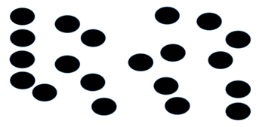count = 20 |  | Bar model for working out a fraction of a number  2/4 of 20 = 10  count = 20
Other division methods above can be used to support fractions this is dependent on specific children

